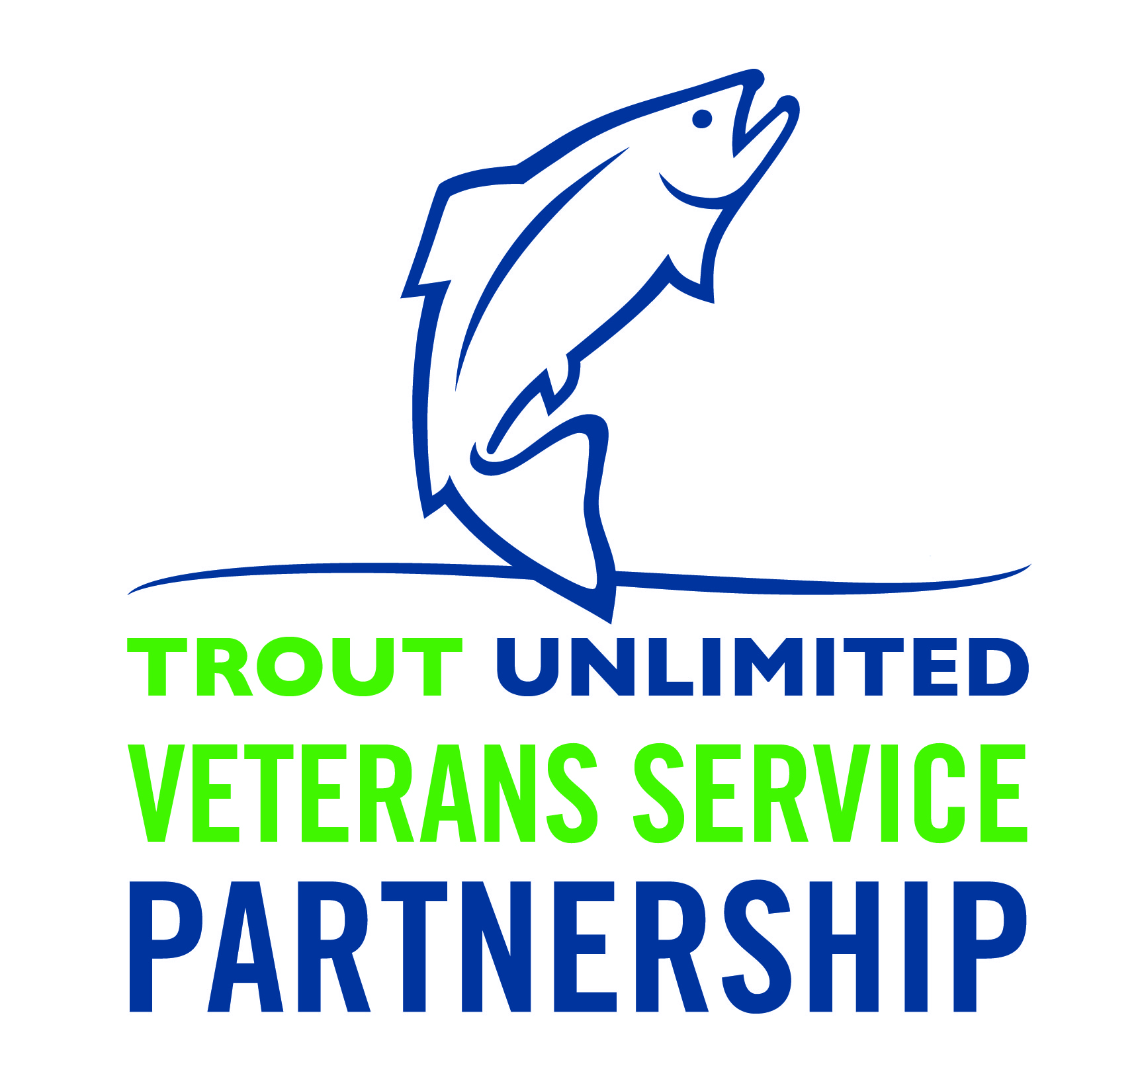

Trout Unlimited Veterans Service Partnership
Sample Chapter VSP Program
Application for Participation in Fishing Outing/ Activity

Veteran/ Active Service Personnel Information:

Name:____________________________________________________________________

Address: __________________________________________________________________

City: ______________________________ State: ____________

Phone: ________________ Cell Phone:________________

Email: _____________________________________________________

Height: __________ Weight: ___________ Shoe Size: _______ Coat Size: ________

Date of Birth: _________________

Branch of Service: ______________________ Years of Service: _____________________

Spouse/ Partner Information

Name:_____________________________________________________________________

Height: __________ Weight: ___________ Shoe Size: _______ Coat Size: ________

Date of Birth: _________________

Emergency Contact Information:

Name:____________________________________________________________________

Phone: ________________ Cell Phone:________________

Email: _____________________________________________________

Fly Fishing Experience:

Veteran/ Active Service Personnel Fly Fishing Experience:

None: _____ Novice/beginner: _____ Average: _____ Experienced: _____

Spouse Fly Fishing Experience:
None: _____ Novice/beginner: _____ Average: _____ Experienced: _____

Participants who fly fish are encouraged to bring their own gear if possible.

I will be bringing my own (Y/N) Fly rod: _____ Fly Reel: _____ Waders/boots: _____
Spouse/ Partner (if applicable) Fly rod: _____ Fly Reel: _____ Waders/boots: _____

I will be bringing the following other gear related to angling: ________________________________

Optional Medical Information Disclosure:
It can be helpful for volunteers and staff associated with the TU VSP to understand any physical or mental impairments participants might have so as to offer the most suitable fishing activity possible. This information will be kept confidential and will not be provided to any other entity.

VSP PROGRAM TO ENTER HERE THE DESCRIPTION OF PHYSICAL CHALLENGES PRESENTED ON THE TRIP/ACTIVITY. I.e “This particular trip is conducted in a wilderness setting, with no immediate access to emergency medical care and may require travel by foot over rough, uneven ground and in variable weather conditions.”

In general terms please describe the nature of your disability if any (example: PTS, TBI, amputee right arm above elbow, etc…):
____________________________________________________________________________________________________________________________________________________________________________________________________________________________________

Do you have any mobility issues that may hamper your ability to walk, hike, wade, stand for extended periods, cast, reel, or manipulate a fly line: (circle one) Y N If yes, please elaborate: ____________________________________________________________________________
________________________________________________________________________________________________________________________________________________________________________________________________________________________________________________________________________________________________________________

Do you have any other medical condition which may hamper your ability to walk, hike, wade, stand for extended periods, cast, reel, manipulate a fly line, remain outdoors for an extended period of time in a wilderness setting, or be exposed to changing and occasionally harsh weather conditions which may include wind, rain, hail, or snow: (circle one) Y N If yes, please elaborate: ________________________________________________________________________________________________________________________________________________________
____________________________________________________________________________________________________________________________________________________________________________________________________________________________________

Are you taking any medications which may hamper your ability to walk, hike, wade, stand for extended periods, cast, reel, or manipulate a fly line: (circle one) Y N If yes, please elaborate: ____________________________________________________________________________
________________________________________________________________________________________________________________________________________________________________________________________________________________________________________________________________________________________________________________

Do you have any food allergies or other allergies which could affect your trip: : (circle one) Y NIf yes, please elaborate: ________________________________________________________________________________________________________________________________________________________________________________________________________________________________________________________________________________________________________________

Do you have any comments or questions regarding your medical condition that you wish to add: ____________________________________________________________________________
____________________________________________________________________________________________________________________________________________________________________________________________________________________________________________________________________________________________________________________________________________________________________________________________________________________________________________________________________________________________________________________________________________________

I have read and understand the above requirements. Should I be selected, I affirm that I am capable of meeting the requirements of my trip.

Signed: ____________________________________ Date: _________________________

Personal Injury Consent Form:

I, _________________________, am at least eighteen years of age and have prepared myself to participate in the Veterans Services Partnership program of the _____________________ Chapter/Council of Trout Unlimited by familiarizing myself with the physical demands involved in participating in the activity. I am in good physical condition and am capable of meeting those physical demands. I understand that activities like this one can involve the risk of death or serious physical injury and agree to assume that risk. I also agree to release and indemnify Trout Unlimited, its officers, trustees, directors, employees, and agents, from and against any and all claims, demands, and judgments arising from injuries or damages in connection with my participation in the project.

________________________(Signature)
Date:______________

Please direct any questions or concerns to:
Dave Kumlien, TU’s Veterans Service Partnership Coordinator [406.570.0023 | dkumlien@tu.org]

