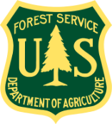
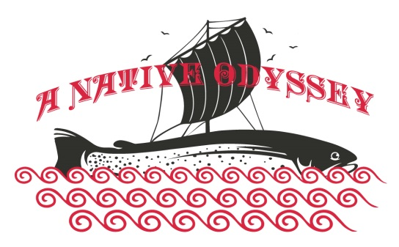
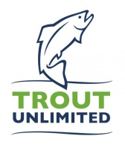

Summary: This summer, five college students from the TU Costa 5 Rivers Program (Trout Unlimited’s College Program located at 90 educational institutions across the country) embarked on a cross country journey of a lifetime. Their mission was to explore public lands in 10 States in pursuit of 18 native species of trout over 10 weeks in an effort to spread information about the importance of wild public lands for preserving native species and clean drinking water.

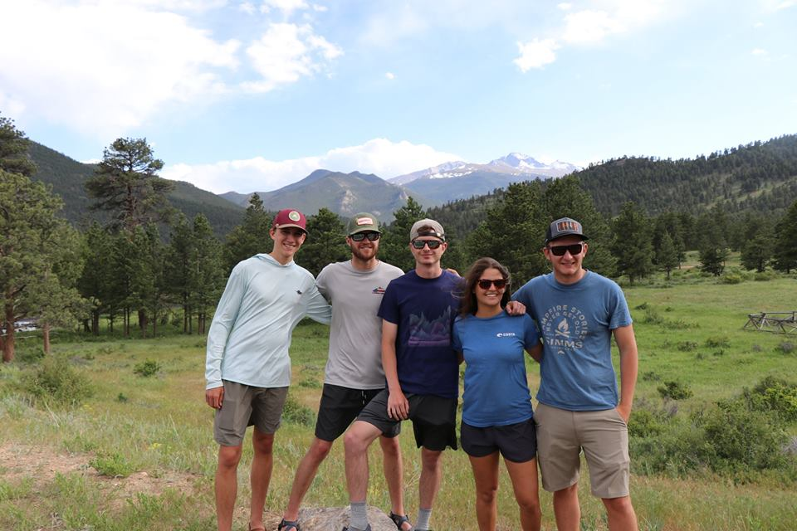
The Team:
The Native Odyssey crew (left to right):
- Brett Winchel (Knoxville, TN)
- Matt Crockett (Knoxville, TN)
- Jacob Lacy (Parker, CO)
- Heather Harkavy (Coral Springs, FL)
- Austin Burroughs (Tallahassee, FL)

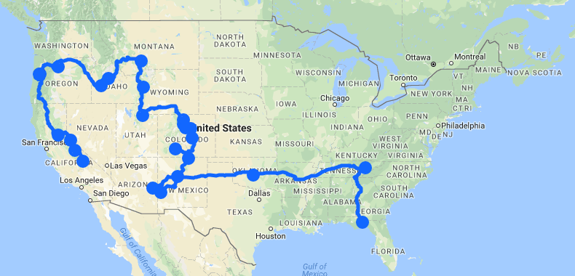
The Odyssey: Their journey covered public lands across 10 states, including the following:
Tennessee | Cherokee National Forest | Southern Appalachian Brook Trout
Arizona | Apache-Sitgreaves National Forest | Apache Trout
New Mexico | Gila National Forest  Carson National Forest  Rio Grande del Norte National Monument | Gila Trout  Rio Grande Cutthroat
Colorado | Rio Grande National Forest  Rocky Mountain National Park  Roosevelt National Forest  State Forest State Park | Rio Grande Cutthroat  Colorado River Cutthroat  Greenback Cutthroat
Utah | Uinta-Wasatch- Cache National Forest | Bear River Cutthroat  Bonneville Cutthroat
Wyoming | Bridger-Teton National Forest  Yellowstone National Park | Yellowstone Cutthroat  Snake River Cutthroat
Montana | Yellowstone National Park | Westslope Cutthroat
Idaho | Sawtooth National Forest | Westslope Cutthroat  Bull Trout
Oregon | Deschutes National Forest | Redband Rainbow  Coastal Cutthroat  Steelhead
California | Siuslaw National Forest  Toiyabe National Forest  Sierra National Forest  Sequoia National Forest | Lahontan Cutthroat  Paiute Trout  Golden Trout

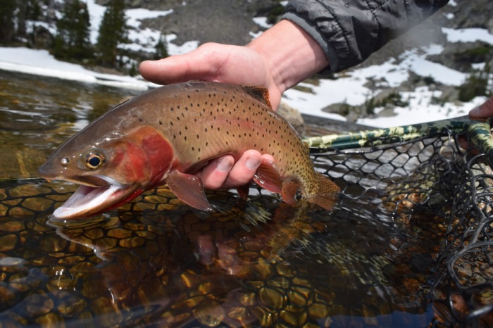
The Native Trout Odyssey successfully caught, photographed, filmed and released a breathtaking diversity of native trout, some of whom are found almost exclusively on National Forest system waters. These native trout represent some of the rarest and most beautiful trout species across the continent.

For more information about the Native Odyssey, and the 5 Rivers program:
Please contact Andrew Loffredo at aloffredo@tu.org
Visit us online: www.tucosta5rivers.org | @tucosta5rivers (on Facebook and Instagram)

