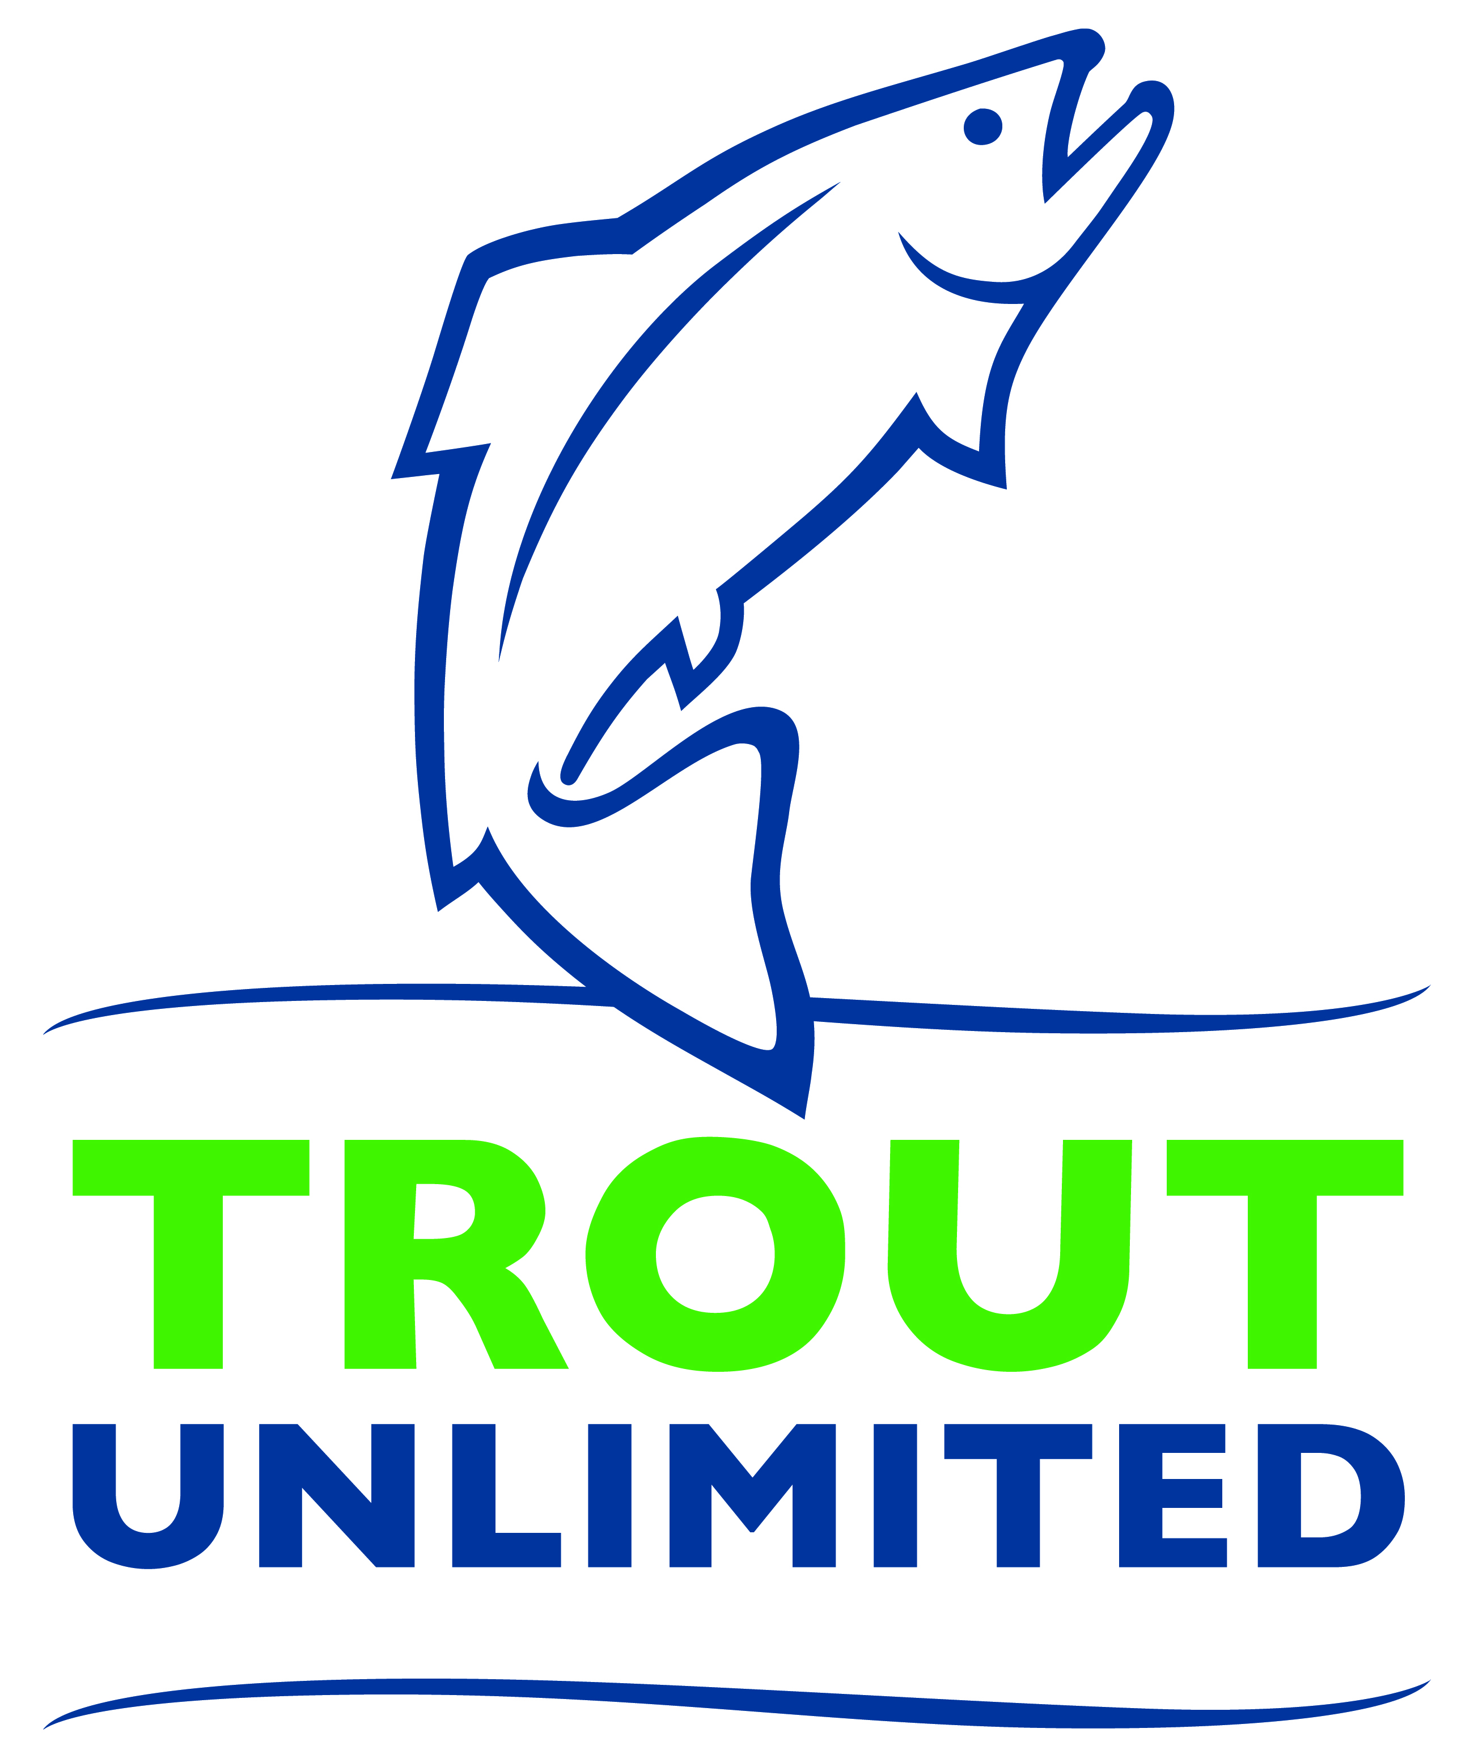
Media Contact: FIRST NAME, LAST NAME
XYZ CHAPTER PRESIDENT
(555) 555-5555
emailaddress@email.com
CHAPTER
NAME HERE

Restoring Local Rivers Topic of Talk MONTH DAY at TIME
State Fisheries Expert, SPEAKER NAME, to Address Trout Unlimited Meeting

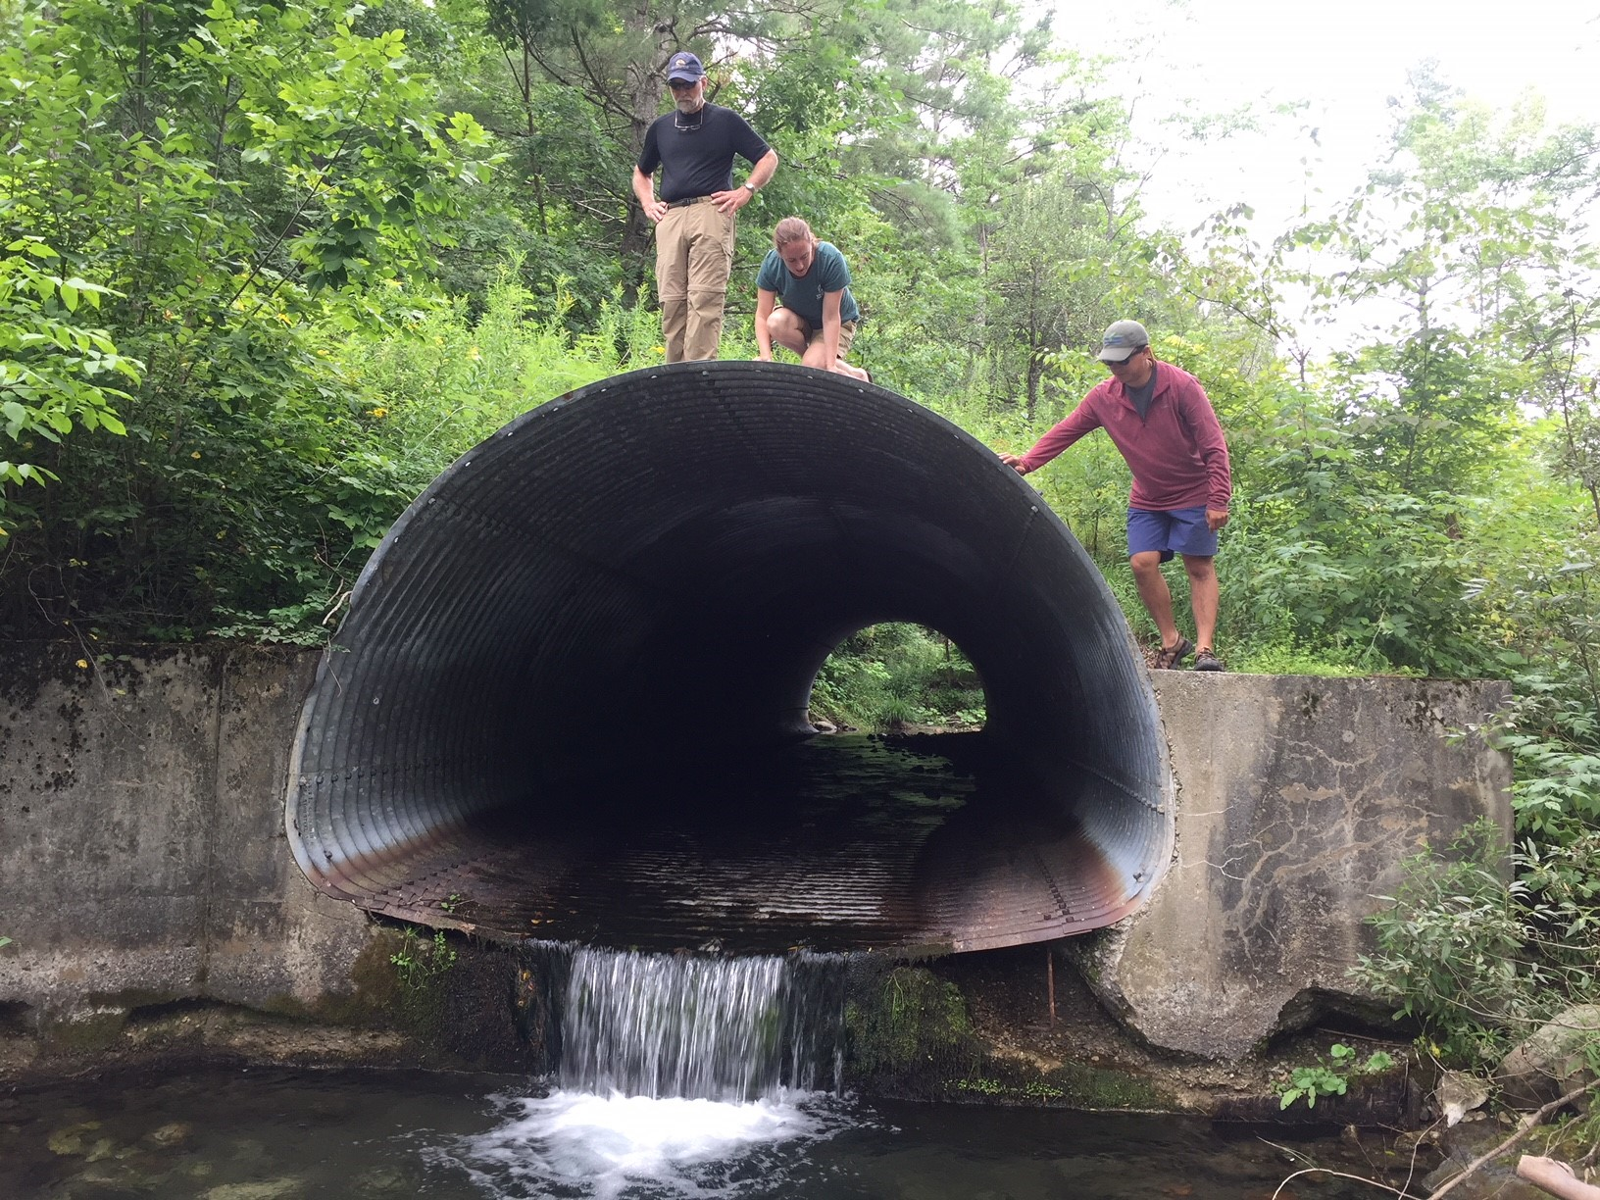
CITY – DATE – The XYZ Chapter of Trout Unlimited will host a special presentation from SPEAKER NAME, SPEAKER TITLE with the ORGANIZATION NAME on the impacts of local river restoration on MONTH, DAY at TIME at the VENUE NAME in TOWN NAME.

“Restoring rivers and ensuring our streams are cold, clean and healthy is something we should all care about,” said FIRST LAST, XYZ Chapter President. “We’re excited to learn more about the work being done and the efforts still needed, and how we can help.”
SPEAKER NAME, a JOB TITLE with the ORGANIZATION NAME, will discuss efforts to restore local rivers with the XYZ Chapter of Trout Unlimited on MONTH, DAY in TOWN.

The XYZ Chapter of Trout Unlimited is a local nonprofit conservation group, with over XXX members and supporters locally, that work to restore rivers, educate youth and engage citizens in volunteer opportunities to improve streams in our communities. Last year, the XYZ Chapter and its volunteers planted XXX trees, picked up XXX pounds of trash and taught XXX area students about conservation.

The XYZ Chapter meets the THIRD TUESDAY of the month for presentations, discussions and networking. Meetings are free and open to the public and guests are encouraged to bring friends and family. Refreshments, a raffle, and volunteer information are also offered at each event.

Along with monthly meetings, the XYZ Chapter holds local volunteer planting days, streamside trash cleanups, citizen science water monitoring programs, fishing classes, fly tying lessons and more. Learn more and view a calendar of coming events at WWW.CHAPTERWEBSITETU.ORG.

About XYZ Chapter of Trout Unlimited (Replace TU national boilerplate below with your local content)
Founded in Michigan in 1959, Trout Unlimited today is a national nonprofit organization with more than 300,000 members and supporters in over 420 local chapters and councils dedicated to conserving, protecting and restoring North America’s coldwater fisheries and their watersheds. Our volunteers and staff work from coast to coast to protect, reconnect, restore and sustain trout and salmon habitat on behalf of today’s anglers and coming generations of sportsmen and women who value the connection between healthy, intact habitat and angling opportunity.

