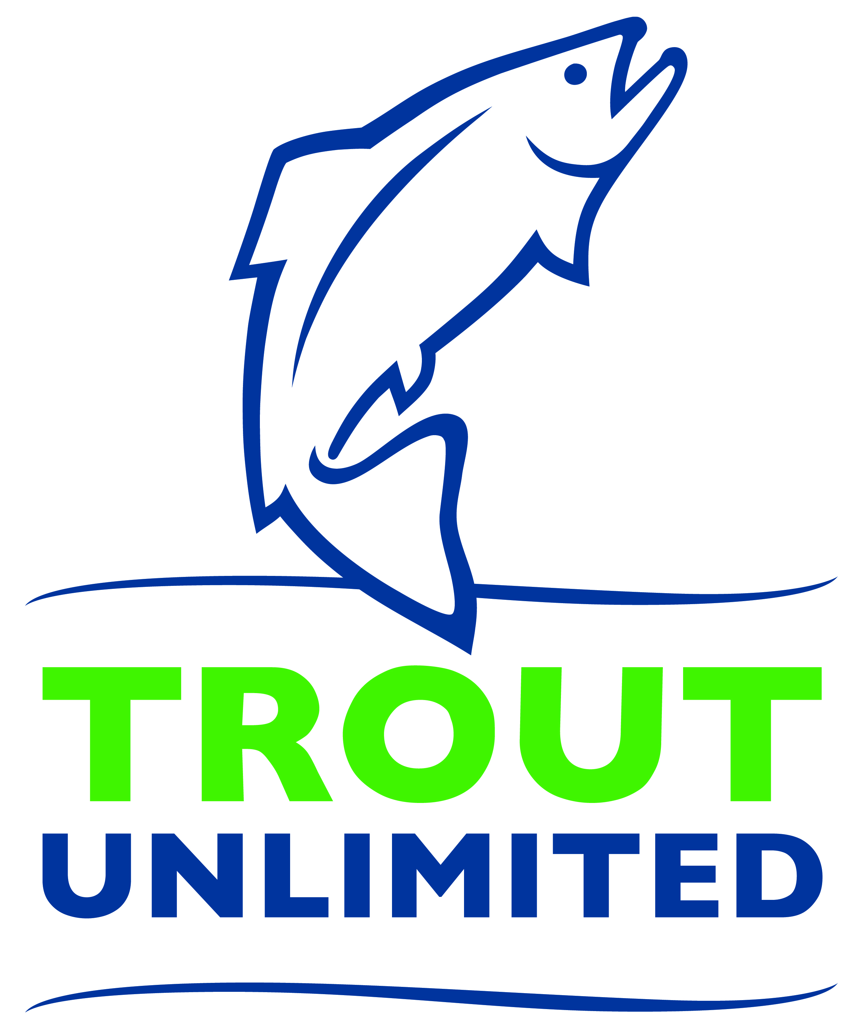
Media Contact: FIRST NAME, LAST NAME
XYZ CHAPTER PRESIDENT
(555) 555-5555
emailaddress@email.com
CHAPTER
NAME HERE

XYZ Chapter Receives $X,XXX Grant from XXX FUNDER NAME XXX
Funds will be used to restore XXX RIVER NAME XXX in XXX TOWN NAME XXX

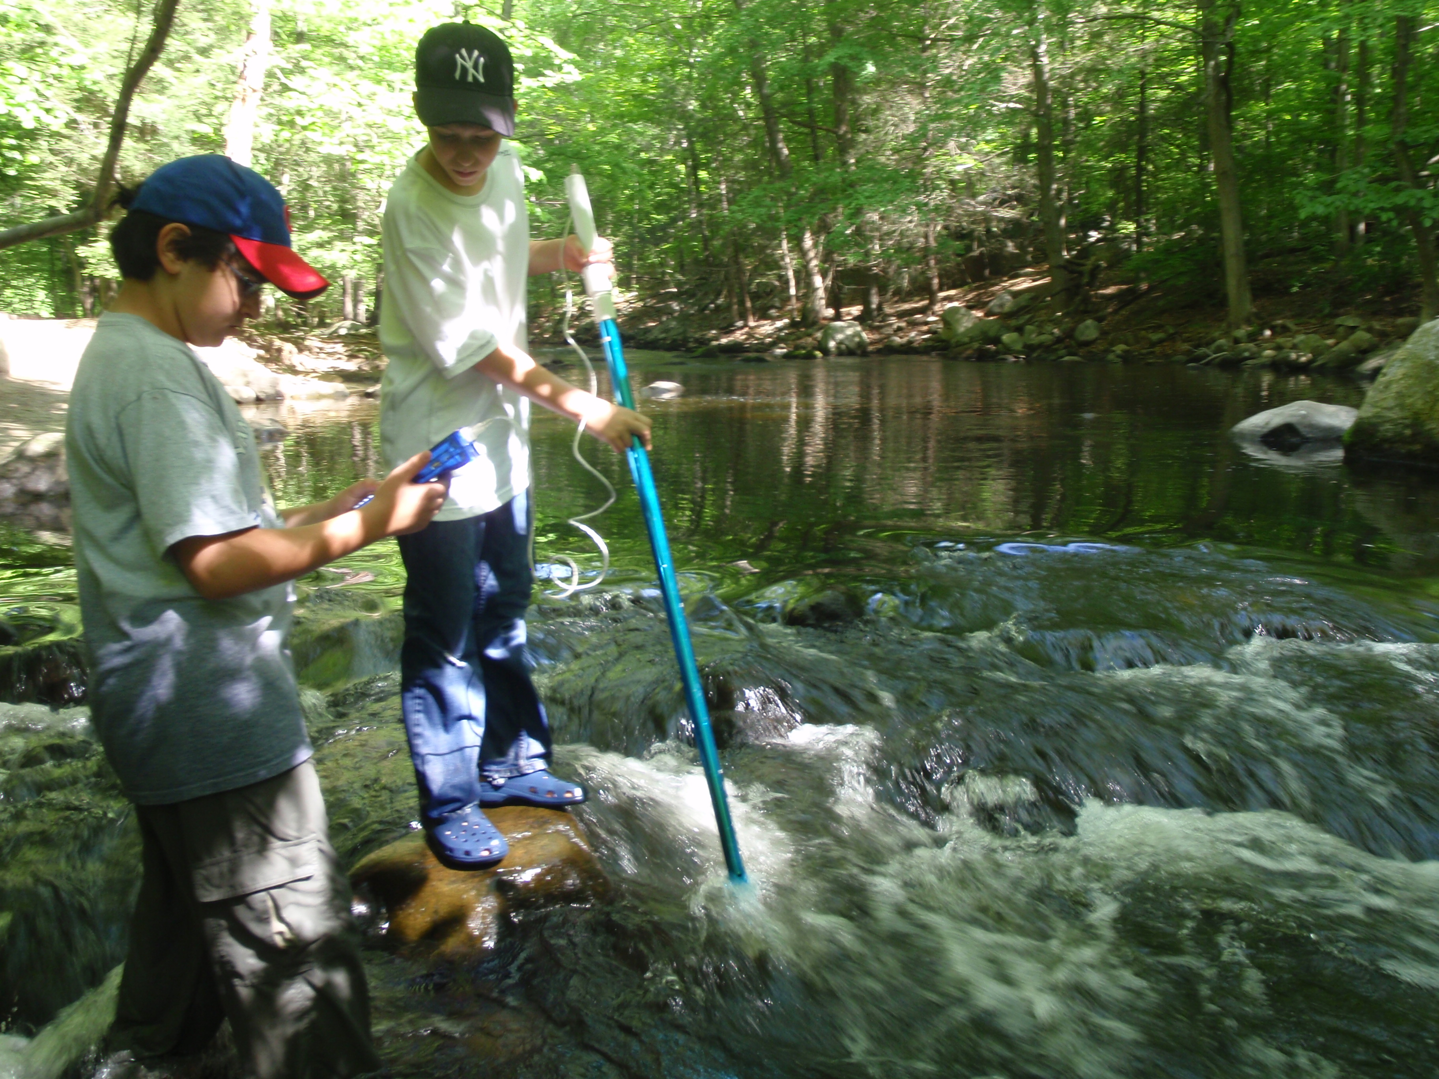
CITY – DATE – The XYZ Chapter of Trout Unlimited (TU) has received a grant of $X,XXX from XXX FUNDER NAME XXX to restore XXXXX River in XXX TOWN NAME XXX. Volunteers from the chapter will be XXX XXX XXX XXXX XXXX. (Example: Planting 500 willow saplings along XYZ River … or … Taking 75 students from XYZ School out to XYZ River for a hands-on outdoor education program…)

The grant was awarded as part of XXX FUNDER’S SPECIFIC PROGRAM TITLE XXX program, a matching grant program that helps support local-level conservation and education projects.

“We’re thrilled to be able to do more great work restoring and improving XYZ River thanks to the XXX FUNDER NAME AND PROGRAM XXX,” said FIRST LAST, XYZ Chapter President. “With this grant, we will be able to really make a difference here in TOWN OR COUNTY NAME.”

Last year, the XYZ Chapter of Trout Unlimited and its XXX members and supporters, contributed more than X,XXX volunteer hours on conservation, education and community awareness programs and projects to protect and restore local rivers.

“TU is such a strong conservation organization thanks to the incredible amount of time and energy volunteers like the XYZ Chapter members contribute each year,” said XXX FUNDER OFFICIAL NAME AND TITLE. “We’re excited to be able to support this project and so many other volunteer-led initiatives to restore local streams and provide meaningful outdoor education experiences for local youth.”

About XYZ Chapter of Trout Unlimited (Replace TU national boilerplate below with your local content)
Founded in Michigan in 1959, Trout Unlimited today is a national nonprofit organization with more than 300,000 members and supporters in over 420 local chapters and councils dedicated to conserving, protecting and restoring North America’s coldwater fisheries and their watersheds. Our volunteers and staff work from coast to coast to protect, reconnect, restore and sustain trout and salmon habitat on behalf of today’s anglers and coming generations of sportsmen and women who value the connection between healthy, intact habitat and angling opportunity.

