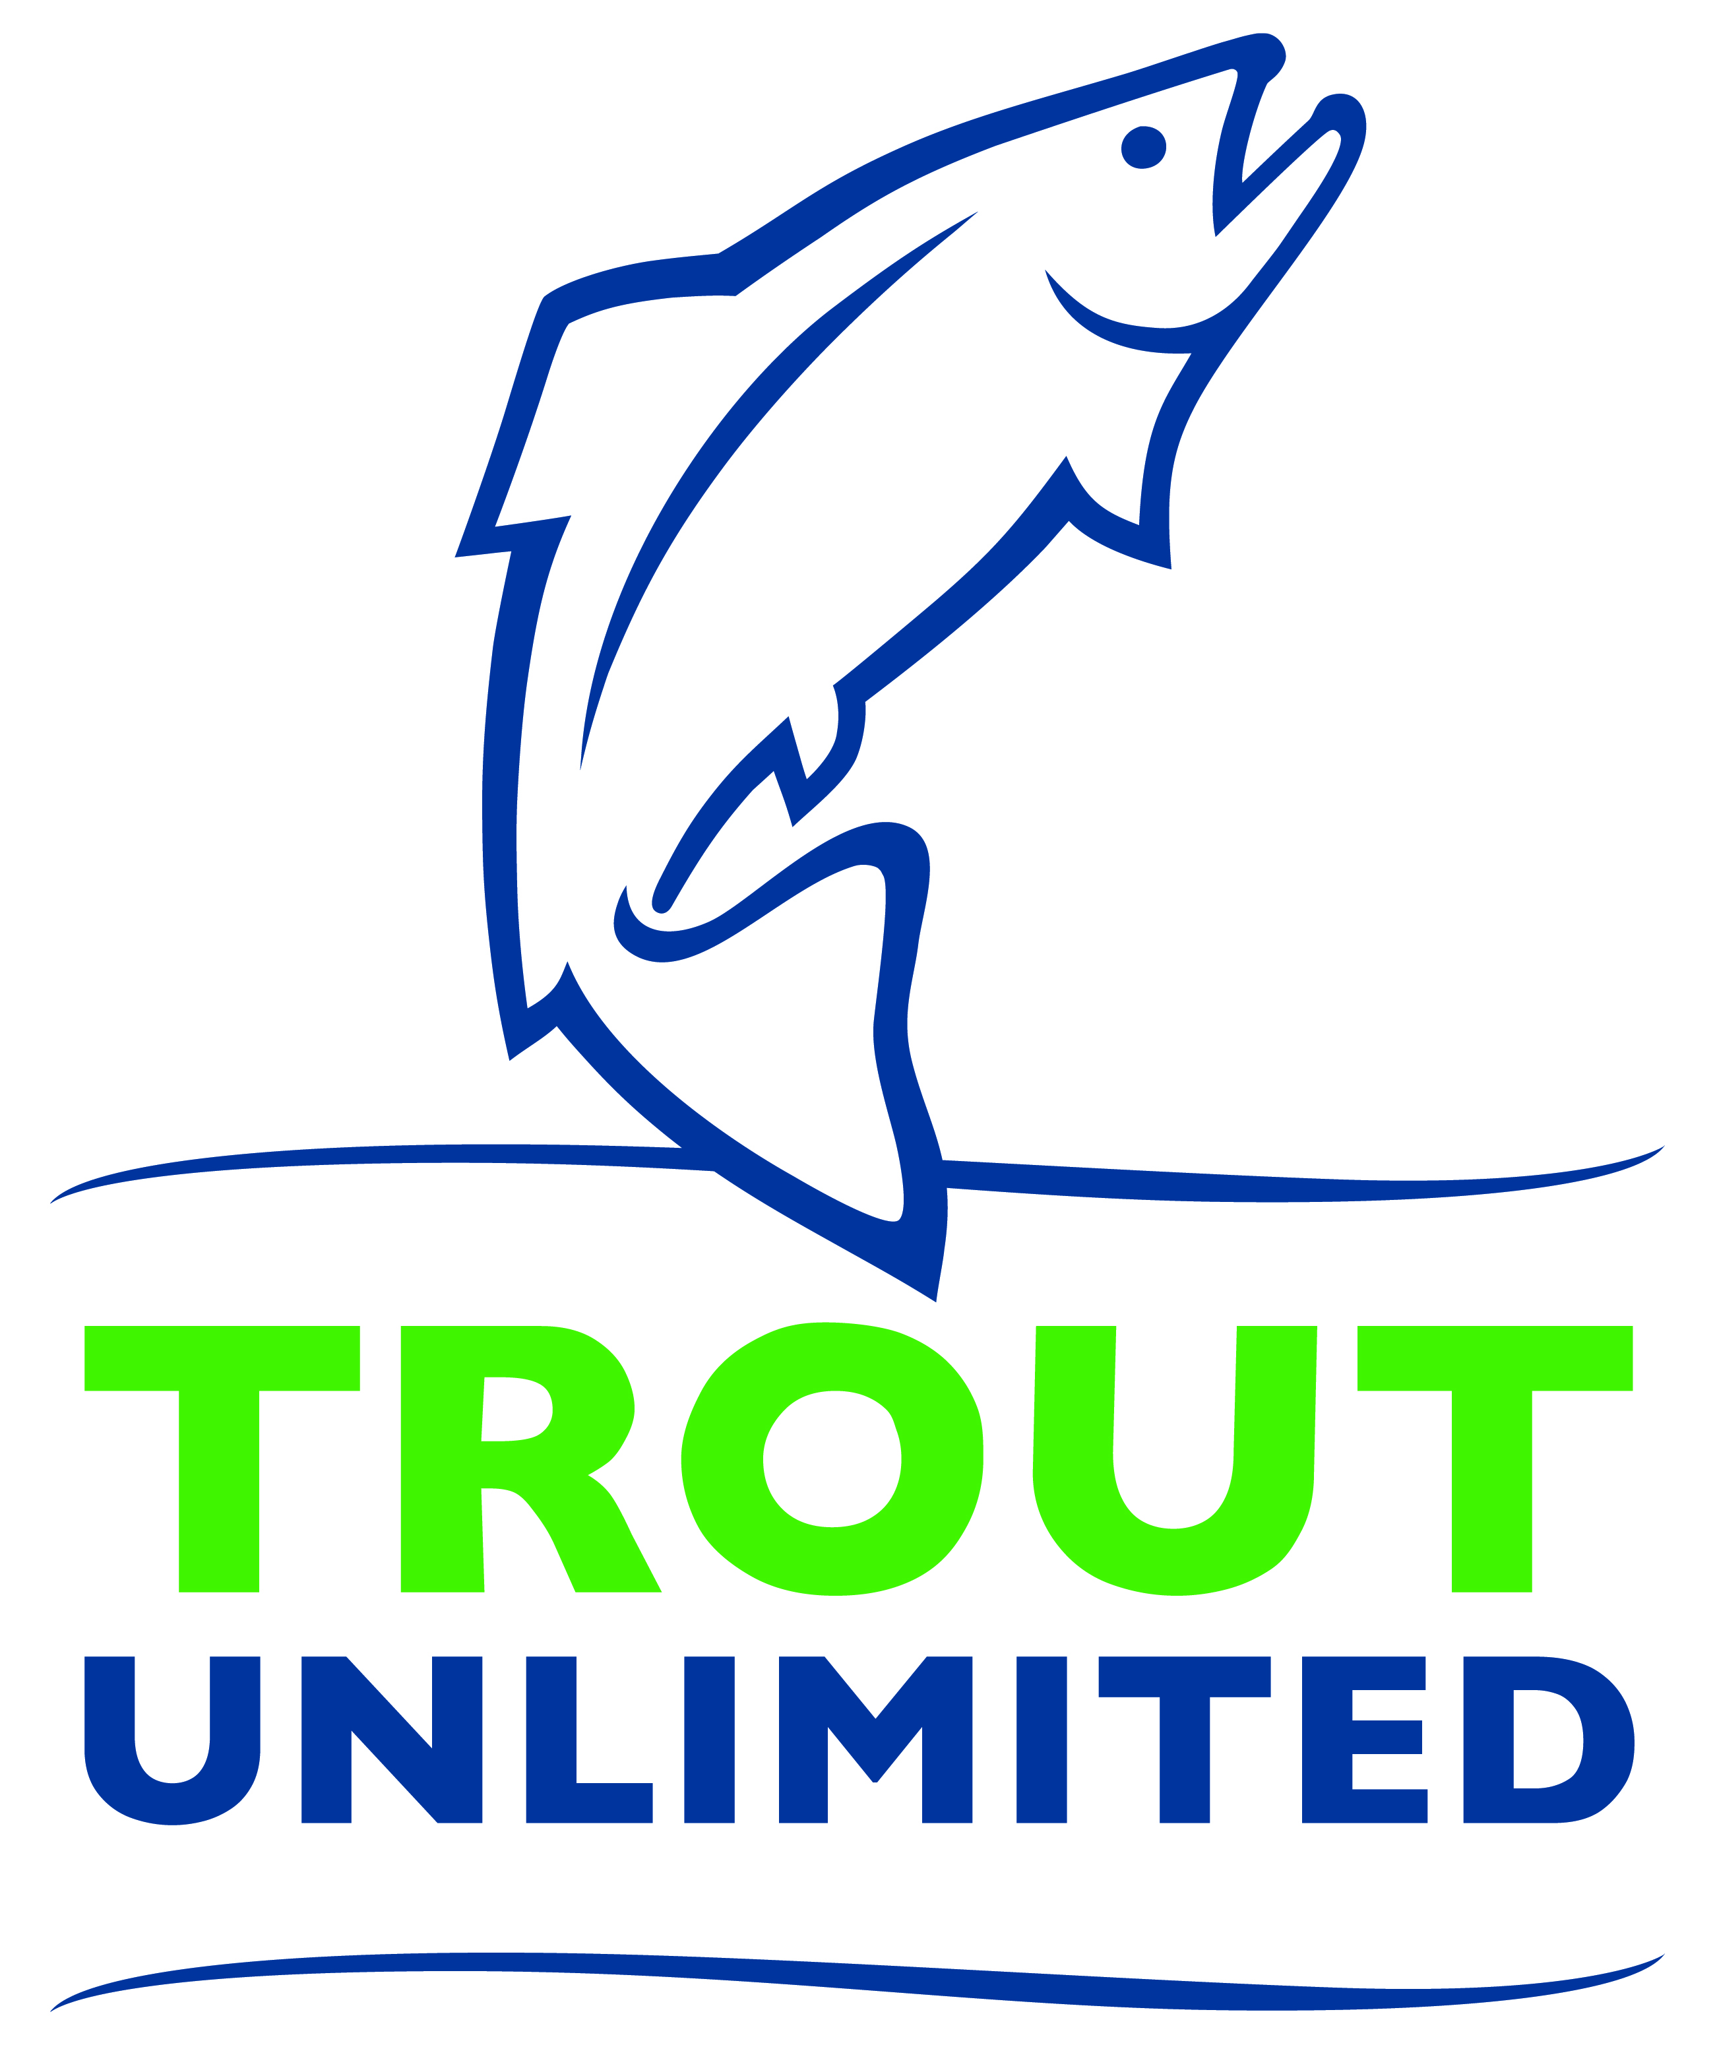
Media Contact: FIRST NAME, LAST NAME
XYZ CHAPTER PRESIDENT
(555) 555-5555
emailaddress@email.com
CHAPTER
NAME HERE

XYZ Chapter of Trout Unlimited Volunteers Pick Up XXX Pounds of Trash
Annual Cleanup Event Helps Improve the Health of the RIVER NAME

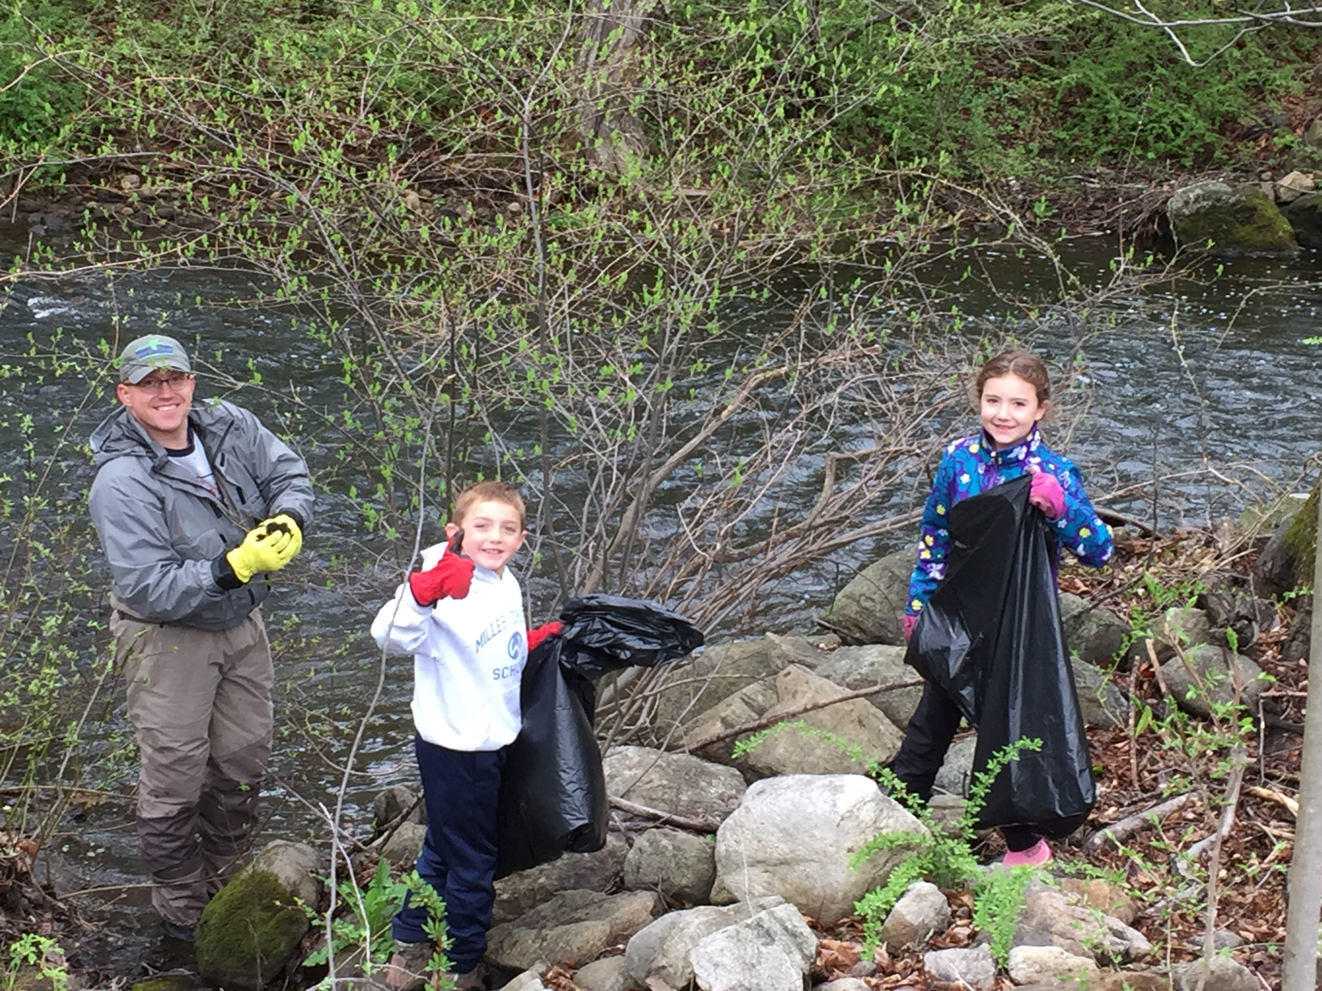
CITY – DATE – Volunteers with the XYZ Chapter of Trout Unlimited scoured the streambanks along RIVER NAME on MONTH, DAY picking up more than XXX pounds of trash.

The annual trash cleanup event is designed to encourage area residents to take part in making sure our local rivers stay clean and healthy.

“Our local rivers are home to an amazing abundance of wildlife – not just trout but also aquatic insects, crayfish, herons, egrets, osprey and mink,” said FIRST LAST, XYZ Chapter President. “Doing our part to keep these rivers clean of trash is just one way to help make sure these rivers remain healthy for all of us to enjoy.”
FIRST LAST of TOWN, and his children NAME and NAME, were among the XX volunteers who helped the XYZ Chapter of Trout Unlimited pick up trash along the RIVER NAME on MONTH, DAY.

The XYZ Chapter of Trout Unlimited is a local nonprofit conservation group, with over XXX members and supporters locally, that work to restore rivers, educate youth and engage citizens in volunteer opportunities to improve streams in our communities.

“I couldn’t believe how much trash we found along and in the river!” said FIRST LAST, of TOWN, a volunteer with the XYZ Chapter. “I hope that as more people become aware of how important this river’s health is to our community they will think twice before tossing that water bottle, coffee cup or sandwich wrapper out their car window.”

Along with its annual trash cleanup, the XYZ Chapter holds local volunteer planting days, citizen science water monitoring programs, youth education programs, fishing classes, fly tying lessons and more. Learn more and view a calendar of coming events at WWW.CHAPTERWEBSITETU.ORG.

About XYZ Chapter of Trout Unlimited (Replace TU national boilerplate below with your local content)
Founded in Michigan in 1959, Trout Unlimited today is a national nonprofit organization with more than 300,000 members and supporters in over 420 local chapters and councils dedicated to conserving, protecting and restoring North America’s coldwater fisheries and their watersheds. Our volunteers and staff work from coast to coast to protect, reconnect, restore and sustain trout and salmon habitat on behalf of today’s anglers and coming generations of sportsmen and women who value the connection between healthy, intact habitat and angling opportunity.

