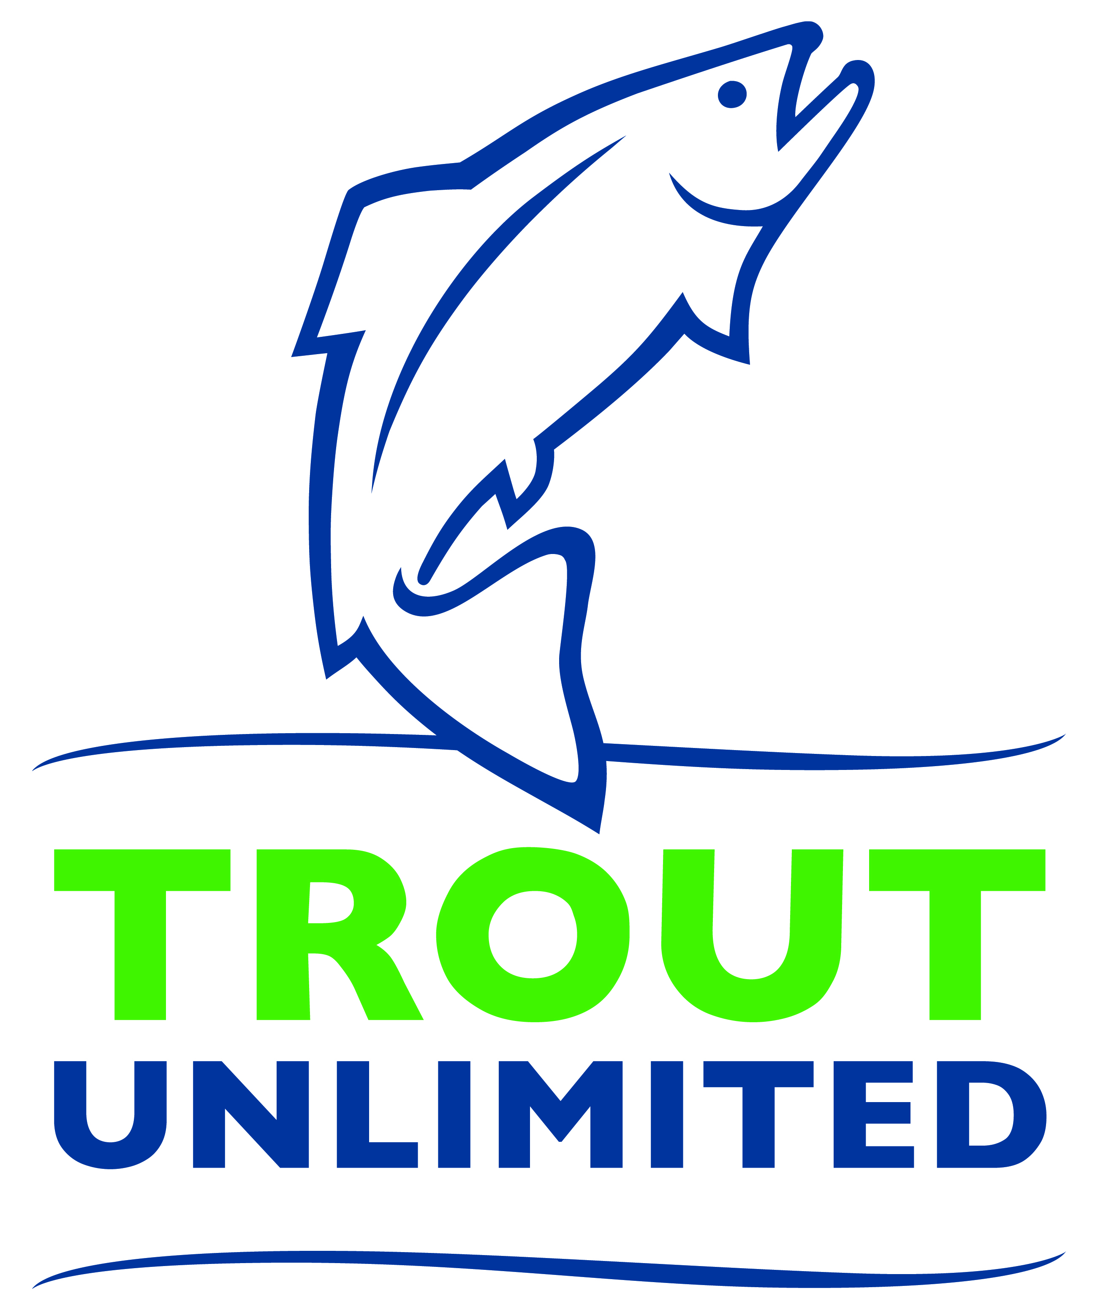
Media Contact: FIRST NAME, LAST NAME
XYZ CHAPTER PRESIDENT
(555) 555-5555
emailaddress@email.com
CHAPTER
NAME HERE

XYZ Chapter of Trout Unlimited Volunteers Contributed X,XXX Hours
Across REGION/COUNTY, conservation, youth, and community programs improve water quality

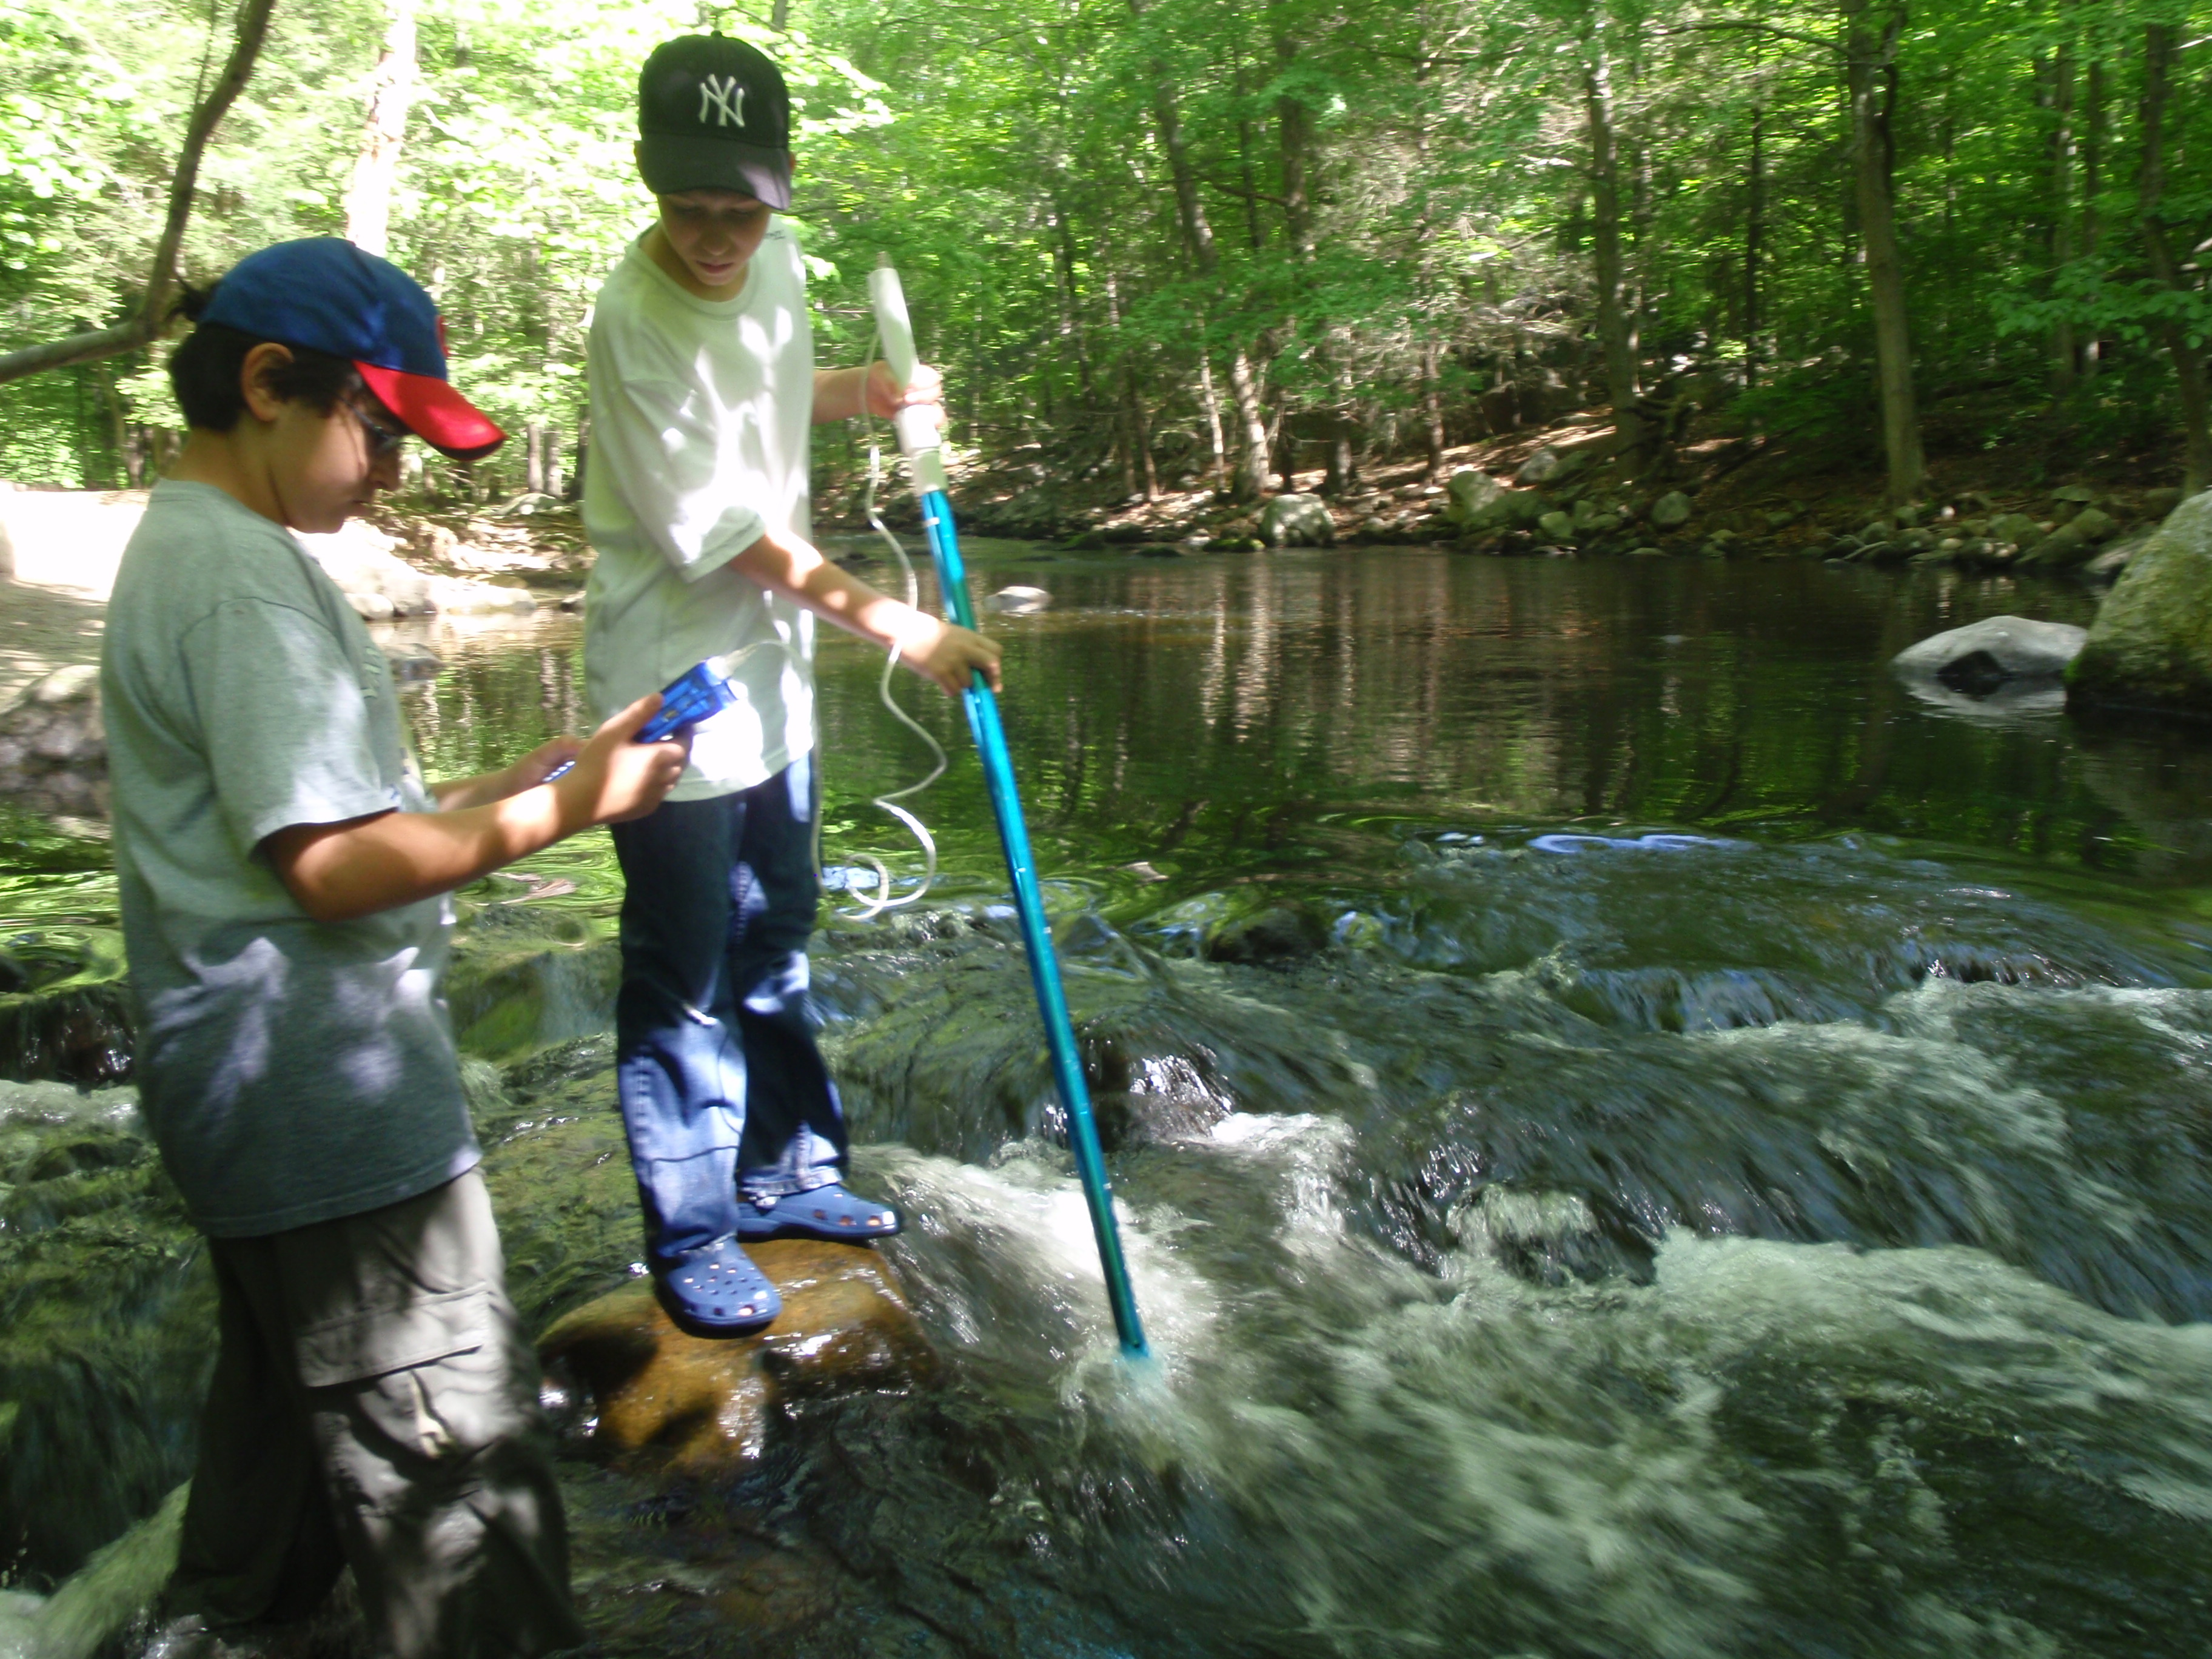
CITY – DATE – Rivers across the XXXCOUNTY NAMEXXX are cleaner and healthier thanks to volunteers with the XYZ CHAPTER Trout Unlimited. In the past year, XYZ CHAPTER volunteers contributed more than X,XXX hours of service to the mission of this national conservation nonprofit that has 420 local chapters and state councils across the country and XX chapters here in the state of XXXSTATE NAMEXXX.

More than XX conservation projects restoring and repairing rivers, and over XX youth education programs and activities to engage the next generation in conservation were held from TOWN NAME IN ONE CORNER OF THE CHAPTER REGION to TOWN NAME IN ANOTHER CORNER OF THE CHAPTER REGION.
Students from XYZ SCHOOL in TOWN NAME take water quality measurements as part of a hands-on environmental education program offered by the XYZ CHAPTER of Trout Unlimited which is working to protect and restore local rivers.

“Trout Unlimited’s philosophy is simple and powerful. If you take care of the fish, the fishing will take care of itself,” said FRIST NAME LAST NAME, president of the XYZ Chapter. “We are a community of people who care deeply about our local rivers and the trout and other wildlife that need clean, healthy rivers to survive and we’re willing to roll up our sleeves to ensure those rivers are in better shape for our children and grandchildren.”

Here in XXX COUNTY / REGION NAME XXX, projects and programs that improved rivers, engaged local communities and educated youth were broad and diverse in their location and impact. They included:
- Planting 500 willow saplings along XYZ RIVER in TOWN NAME to improve water quality, reduce erosion and minimize the impacts of flooding
- Bringing 250 students from URBAN SCHOOL DISTRICT ABC out to the XYZ RIVER to learn about the ecosystem and how clean, cold water is essential to support not only trout, but also aquatic insects, mink, osprey, heron and a host of other native STATE NAME wildlife
- Tearing down the XYZ DAM on the XYZ RIVER in TOWN NAME – a project took more than 10 years, a dozen nonprofit, state and municipal partners and over $2 million in grant funds to accomplish – in order to allow native brook trout to reach their spawning grounds upstream for the first time in 150 years
- Partnered with the TOWN NAME Vetarans Hospital to help more than 50 veterans heal and recover from the trauma of combat through therapeutic fly fishing lessons and fishing trips

These projects and so many more were thanks to the members and volunteers of Trout Unlimited and the thousands of supporters who provide the time, talent and resources to make XXX COUNTY/REGION NAME’SXXX rivers healthier. To support Trout Unlimited, find your local chapter or to volunteers, visit WWW.XYZCHAPTERWEBSITEOFTU.ORG

About XYZ Chapter of Trout Unlimited (Replace TU national boilerplate below with your local content)
Founded in Michigan in 1959, Trout Unlimited today is a national nonprofit organization with more than 300,000 members and supporters in over 420 local chapters and councils dedicated to conserving, protecting and restoring North America’s coldwater fisheries and their watersheds. Our volunteers and staff work from coast to coast to protect, reconnect, restore and sustain trout and salmon habitat on behalf of today’s anglers and coming generations of sportsmen and women who value the connection between healthy, intact habitat and angling opportunity.

