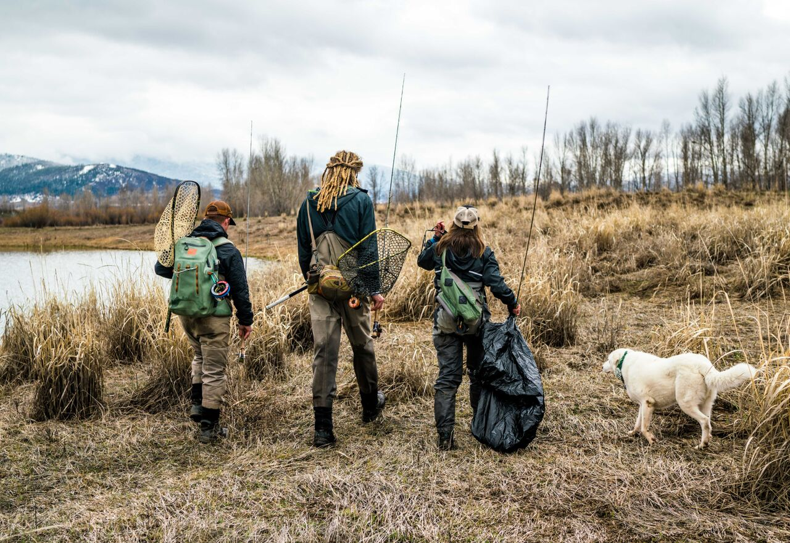
Trout Unlimited Costa 5 Rivers
Leadership Handbook
Trout Unlimited Costa 5 Rivers
Leadership Handbook

Photo: Flylords
Made Possible by

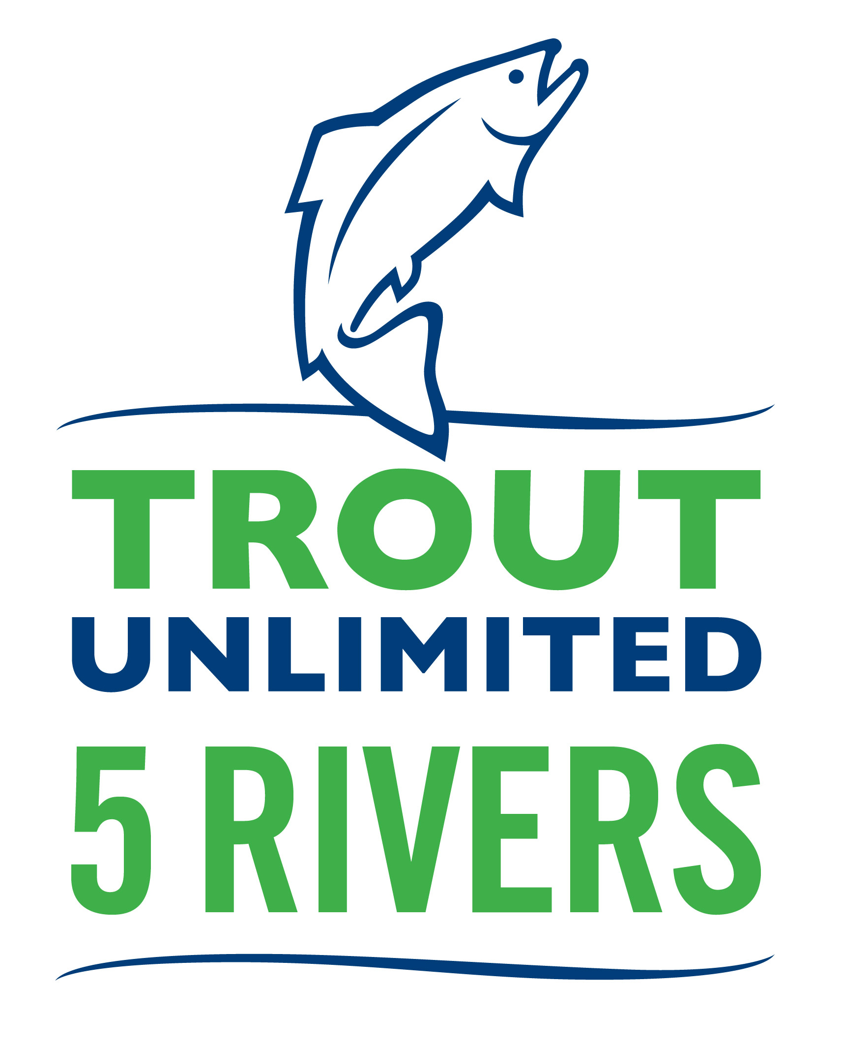
5 RIVERS LEADERSHIP HANDBOOK
Hello 5 Rivers Club Leader! Whether you are starting a new 5 Rivers club or taking over a leadership role within your existing club, this guide provides helpful insights in to improving the capacity of your club. This guide acts as a companion document to the 5 Rivers Club Set-Up Guide available on the 5 Rivers website. Please be sure and take a close look at the 5 Rivers Guide before you continue to read this document. ________________________________________________________________________
How to Create a Successful Club
In order to create a successful club you have to, above all else, make it FUN! If it isn’t fun, it will be incredibly difficult to make your club successful.
Social Element
Photo: Dan Zazworsky
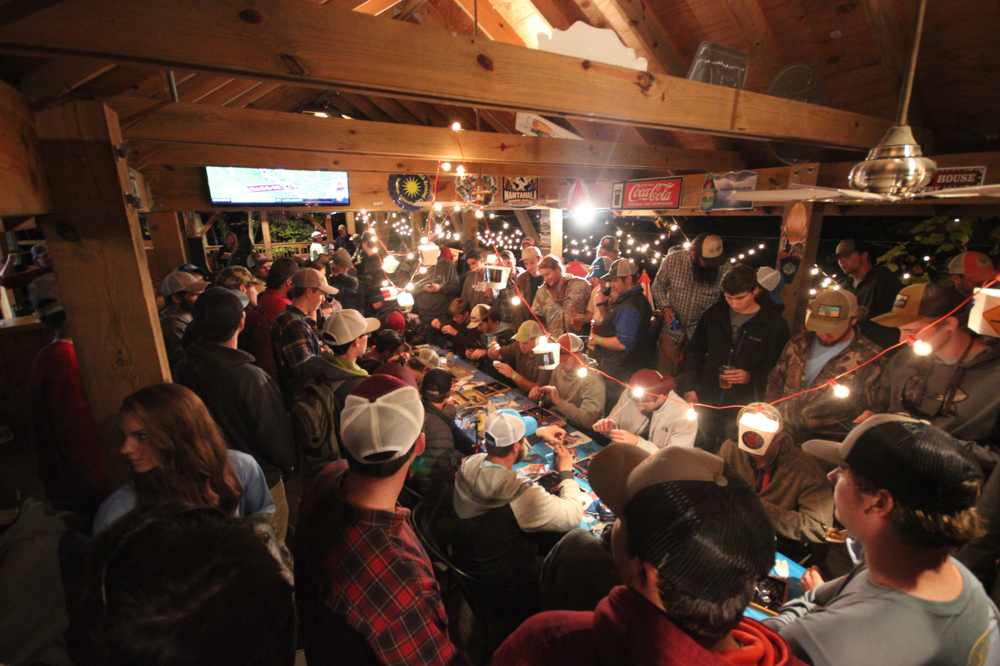
Clubs that have a fun social element as part of their structure are often the most successful. In addition to your conservation, community outreach, and fundraising efforts, we encourage you to think about including fun social programming. If you do it right, your club will become a group of close friends rather than simply “A Club.”
Photo: Dan Zazworsky

Intramurals
Intramural sports teams can be a fun and easy way to get people to rally around the club. Club members who maybe aren’t as active will begin to come around for these types of events. Once they have fun at these types of events, you will start to see more participation at stream clean ups, club fundraisers, etc.
Other Fun Events Not Related to Fishing
In addition to intramurals, look for opportunities to get your club together outside of fishing related events. Holiday get togethers, Relay-for-Life, and other community events are great opportunities to raise club morale and get new people in the door.
Marketing Your Club
Understanding Your Campus’ Unique Demographic
Every campus is unique. Understanding what is popular on campus and effectively leveraging that will make your club more successful. For example, if Greek life is big on your campus, getting influential Fraternity and Sorority members to join your club will help bring people from those organizations into yours. This concept can be applied to other campus organizations as well such as the club sports teams, ski club, other outdoor recreation focused clubs, student government, etc.
Club Apparel
Club shirts, hats, and stickers are a great way to market your club to the rest of your campus community, especially when you pair it with the “social influencers” (president of the student body, fraternity, sorority, or sports team members) on campus. Try to sell club apparel that is attractive to the whole campus community because doing so will maximize revenue from sales. Also, do not overlook the school’s alum network and opportunities to sell club apparel at sports events where large numbers of alums are in attendance.
Photo: Flylords
If you need help finding a manufacturer, let the 5 Rivers Coordinator know. We have access to some top fishing brand apparel companies that would be glad to produce your club apparel and stickers.
Instagram
Instagram is a powerful way to market your club on campus. Growing your follower count will increase your chances of being found as a suggested page. Post cool, high quality content on your page and hold Instagram giveaways (the 5 Rivers Coordinator can help you with this) so that you can grow your page quickly. Most colleges and universities have DSLR cameras and Go Pros that you can rent for school-related purposes. Get in touch with the 5 Rivers Coordinator to brainstorm effective ways to use Instagram on campus.
Note: If you want to help promote your club via the 5 Rivers Instagram page, please look at the 5 Rivers Social Media and Blog Feature Guidelines document.
Videos
Short videos and Instagram shorts are another easy and fun way to market your club. Collect footage from your club members and compile and edit it to show what your club is about. Tag your university when you upload the video to YouTube, Instagram, etc. and have all your members share it. You will be surprised how effective videos can be.
“Outside the Box” Thinking
Effective marketing is all about creative and out of the box ideas. For instance, as a club conservation event, you and your club can adopt a section of stream near a well-travelled area. People will notice your adopted section is much cleaner and will see signage that your club adopted that section. Word will spread about the great work your club is doing and more people will want to join. The more creative and more engaging the event/initiative is for the non-fishing public, the more returns you will see in terms of club awareness and growth.
How to Run a Successful Meeting
Club meetings throughout the 5 Rivers network are typically held once or twice a month during the school year. Work with both your current club executives (see Guide for suggested club leadership structure) and members to determine what works best for your club.
Real Agenda
Before a meeting takes place, the executive board should come up with a detailed and timed agenda that should be emailed out prior to the meeting. Having a pre-planned agenda will allow members to clearly see what will be discussed at the meeting, and more importantly, it will keep the executive board on task. There is nothing worse than a club member coming to his or her first meeting just to find that the club executive board is off task and doesn’t have any real information to share. That member may never come back, especially if they are a typical college student whose time is super valuable.
Change Meeting Name to “Get Together” or “Meet Up” or “____________”
Change the name of a meeting to “get together” or “meet up” etc. The word “meeting” has a connotation of being boring and not fun. Get a more lively name for your club’s time together.
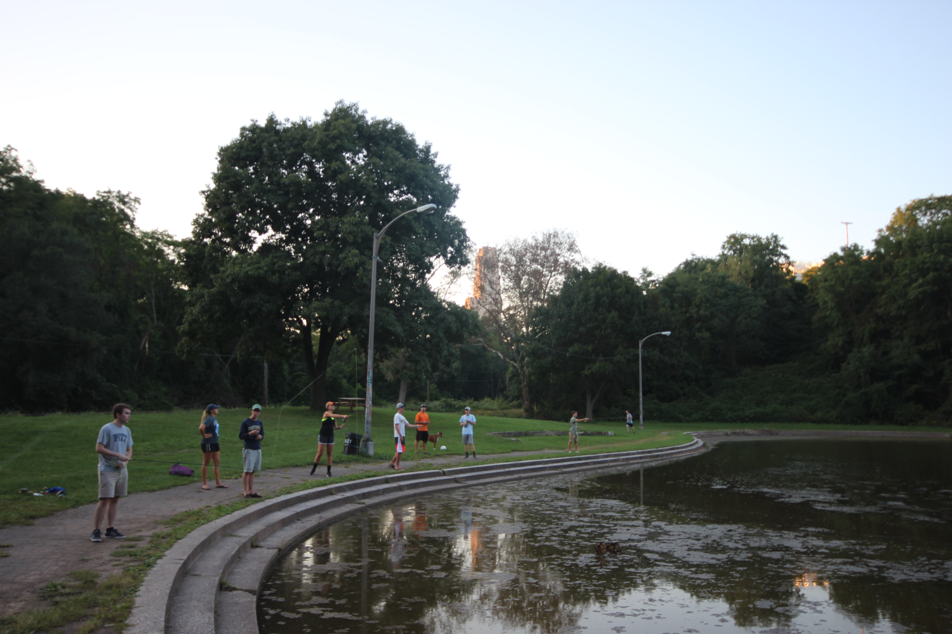
Off-Campus Meet-Ups
After a long, stressful, and test-ridden day on campus, where is the last place you want to go at the end of the day? More than likely, you just said “back to campus.” If you can, host meetings at a club member’s house or at a local restaurant or fly shop/tackle store. Having meetings on campus makes members less comfortable and makes meetings feel like another class.
Photo: Dan Zazworsky
Fun Programing
It is important to mix up the agenda for each meeting so it doesn’t become boring/ stale. Mixing it up and covering topics such as fishing videos, rod building, guest presenters, and fly tying nights are a great way keep things fresh! Survey members and see what kind of presenters they’d like to hear from. Shop owner? Guide? State fish biologist? Local TU Staffer?
Dues / Value Proposition
If you are thinking about setting up dues for you club, run it by your club membership. It is helpful to set up three different dues scenarios ($10, $20, or $30). Keep in mind the concept of a value proposition. If your club members think that paying dues will help them get more out of the club, then they will be glad to pay. Make the rewards for their dues very real and tangible. Food at meetings and club apparel are good things to build into your club budget that will not only get members to pay but to show up on a regular basis.
Check out the TU blog (www.tu.org/blog) for a post by our 5 Rivers interns. They do a great job breaking down how to run a meeting, amongst other topics.
Keys to Recruitment and Increasing Participation
Social Accountability
Clubs that effectively create a great social environment within the club will begin to see the club membership as a group of friends, rather than a club. When everyone becomes friends within the club, you will see people come around more often as it will be viewed as an opportunity to get together with friends rather than “having to go to another club meeting.”
Incentivize Attendance
Whether it is food at meetings, a club Post Fly Box membership, a giveaway for those who show up, or a semester raffle (look at the 5 Rivers blog post about how to run a meeting), finding ways to incentivize attendance is another great way to get people to show up on a consistent basis.
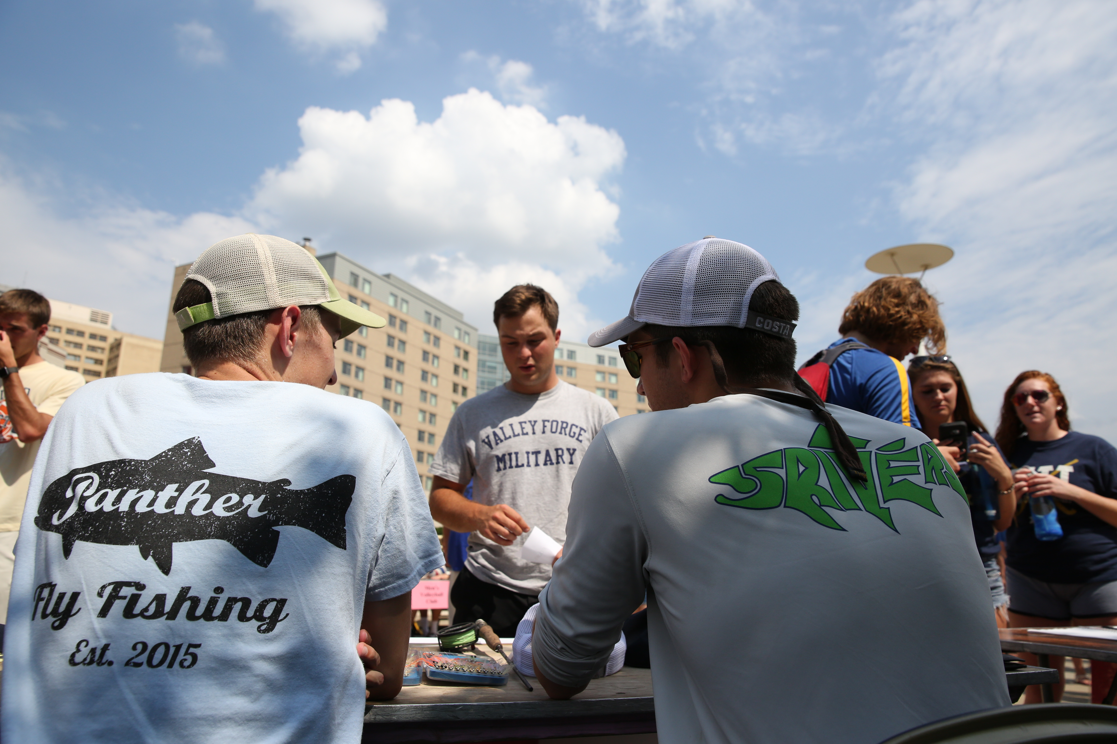
Activity Fairs
Photo: Dan Zazworsky
Freshmen and transfer students are eager to make friends upon arrival on campus. Activity Fairs are generally held at the beginning of the year (and sometimes the beginning of the spring semester) and represent a great opportunity for your club to recruit members. The fair is the single best opportunity to boost your email list and membership levels. You generally have to sign up to have a table at the Activity Fair. Be sure to ask your Registered Student Organization office for more details so you don’t miss the deadline.
Note: Having a fun event planned within a week of the activities fair will help retain a larger percentage of those who sign up for your email list as members for the year. Fun events where they can meet the members is the best for these type of intro events (whiffle ball, volley ball, bowling night, etc.) without having them feel intimidated.
Leveraging Members’ Social Networks
One successful way to recruit new members is by leveraging social networks. Many club members will be involved with Greek life, clubs, student government, sports, etc. Use this to your advantage. Try to get each member to bring at least one friend out to a meeting or event during the school year.
Agriculture and Life Sciences/Biology/ Environmental Studies
Your school’s science departments are a good place to look for people who are into the outdoors. Posting up club flyers about an upcoming meeting or event outside of classrooms can be a good way to market the club and get new members. Be sure and target fisheries students and see if your campus has an American Fisheries Society student chapter.
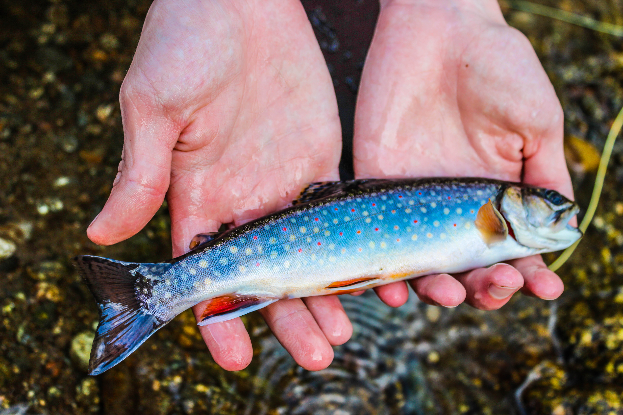
Photo: Dan Zazworsky
Many schools have other clubs and organizations whose members are ideal candidates for 5 Rivers. Check in with your school’s outdoor program office and see if they offer fishing trips. Be proactive in locating students who are oriented toward getting outside.
School Budgets
School funding is often available for clubs and is a good way to finance both member-only and campus-open events.
Initial Budget & Terms of Use
Said money becomes available once the club is officially recognized by the school, typically after a probationary period for the club-governing administration to verify that the club will have student involvement and that the club leaders will carry out events. After a probationary period, an initial budget will be allocated to your club's account. Depending on your school's "student activities" department, the terms for club spending and use of the budget may be by request and require approval from the administration for each transaction.
Budget Increase
Once a club is assigned an initial budget, it is very feasible to increase the budget for the next school year. Schools want to see clubs carry out events that increase student involvement. In other words, the more students you can prove are attending budget-supported events, the more money will be approved for your club for the next year. When applying for next year's budget, be sure to overshoot the amount of money you will actually need and plan more events that require financial support.
Club Collaboration
Participation fees and member dues are reliable sources of funding to supplement a budget, but it is also often allowed for a club to spend the remaining budget of another club with a similar mission (Outdoor Club, Environmental Club, etc.). This requires approval and participation of the leaders of the other club by either co-sponsoring your club's event or allowing a transfer of funds to your club's account. Schools like to see interdisciplinary activities and interaction across clubs and will help when applying for a larger budget the next year. Partnering with organizations outside of your school's jurisdiction is another way to finance events and activities. Examples of organizations looking to fund/host public events with similar themes to your 5 Rivers club would include: a 5 Rivers club at a nearby school, a local TU chapter, fly shops and sporting goods stores, and a local Parks and Recreation Department.
Succession Plan and Club Longevity
Executive Board consisting of multiple academic years
Get underclassmen involved early! Have them head up an event or have them become a chair position within the club. Gradually work them into positions with more responsibility. Recruit and begin to educate your successor in the FALL Semester prior to your graduation! This is key for your organization’s longevity and your legacy as a leader of your club. Always emphasize to seniors that it is their job to replace themselves on the club so that it continues after graduation.
Benefits of Affiliation
By having your club affiliated with the 5 Rivers program, you receive a bunch of benefits:
Club Banner
Once your club and your logo are approved by the university, the 5 Rivers program provides your club with a 3x5 banner for your club activities. Reach out to the 5 Rivers Coordinator for more information and to place orders. (note: one banner per club).
Postfly Box
As a 5 Rivers Club you also get access to a custom club box offered by Postfly. There are multiple boxes designed for clubs of different sizes, so it doesn’t matter if you have 10 members or 50. Orders are placed at the beginning of every semester, and the 5 Rivers Coordinator will make an announcement on how to place orders and due dates.
Student Discount Program
Photo: Wray Sinclair
Upon Completion of your “5 Rivers” your club gets access to the 5 Rivers Discount Program, which consists of discounts on various popular fly fishing manufactures. Discount protocols vary so reach out to the 5 Rivers Coordinator for more information. DO NOT reach out to program sponsors directly and do not discuss them outside of your club. Doing so, will put the discount program in jeopardy for everyone in the program, including other schools.
5 Rivers Events
The 5 Rivers Rally on the east coast and the 5 Rivers Rendezvous in the Rocky Mountains are our annual club get togethers that attract over 250 club members from 32 schools. Thanks to Costa’s sponsorship, 5 Rivers club members attend free of charge!
Trout Unlimited Membership
All of the members of your clubs executive board get a free, one year membership to Trout Unlimited! Please contact the 5 Rivers Coordinator for more information.
Network
The 5 Rivers network is the most powerful voice in college fly fishing. With clubs on over 100 college and university campuses nationwide, the network provides endless opportunities to make your club better. Utilize the network to plan fishing trips, meetups, or ask for advice!
Leadership and Costa Ambassadorship Role and Responsibility
Costa Ambassadorship
As the Founder/president of your college fishing club, you have the option to be a Costa Ambassador. As Ambassador, you get a free pair of Costa sunglasses, but you must do a great job as leader of your organization and act as an advocate for conservation. Ambassadors submit semester reports describing club activities and future planned events. Costa and the 5 Rivers Coordinator will then pick five club leaders each semester that will be recognized as the “Top Costa Ambassador.” Top Ambassadors receive prizes ranging from custom packs to Yeti Coolers and much more!
Please take a look at Costa Campus Ambassador Manual for more information.
5 Rivers Initiative Ideas
- Community Outreach
  - Learn to fly fish/tie on Campus
  - Project Healing Waters Event
  - Pig Farm Ink Iron Fly
  - Advocacy
- Conservation
  - Stream Cleanup
  - Adopt-a-stream
  - Pig Farm Ink Get Trashed Event
  - Monofilament recycle bin at public fishing access sites
- Fundraiser
  - Club Apparel
  - Profit share at a restaurant
  - Go Fund Me
  - Tilt
- TU Connection
  - Invite the TU chapter to your local events
  - Participate in one of their events
Note: You can piggy back off of your TU chapters events and count them towards your conservation, community outreach, or fundraiser. Some events (that they host or you host) may qualify for more than one of the “5 Rivers”
Contact
For additional tips and tricks, take a look at the TU blog under “5 Rivers”(www.tu.org/blog). We will be covering different topics periodically throughout the school year.
If you have any questions, please feel to reach out to the 5 Rivers Coordinator, Andrew Loffredo at Andrew.Loffredo@tu.org .

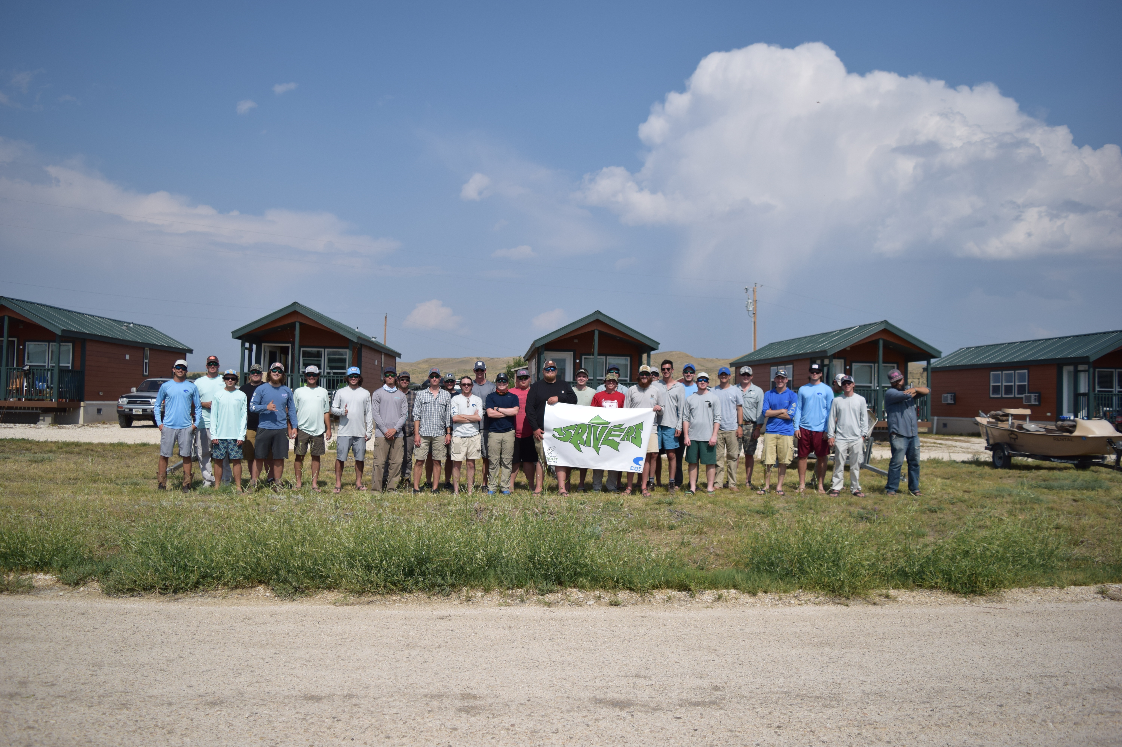
Photo: Andrew Loffredo

