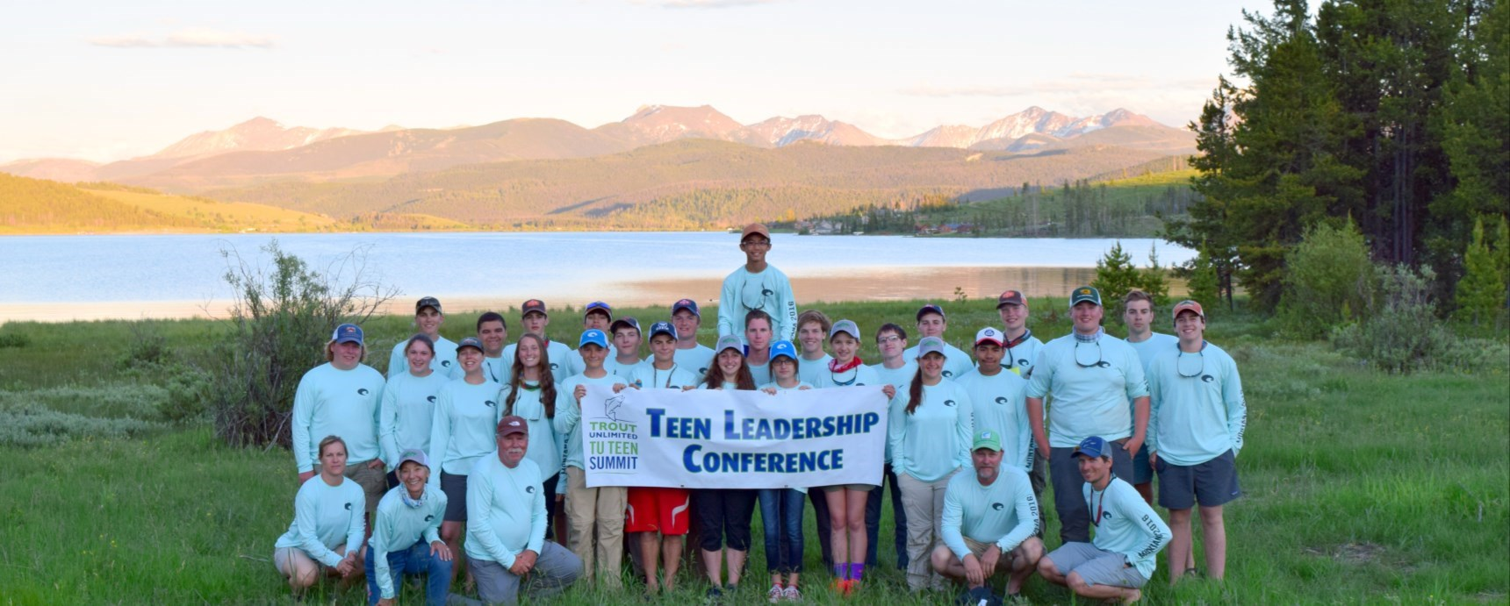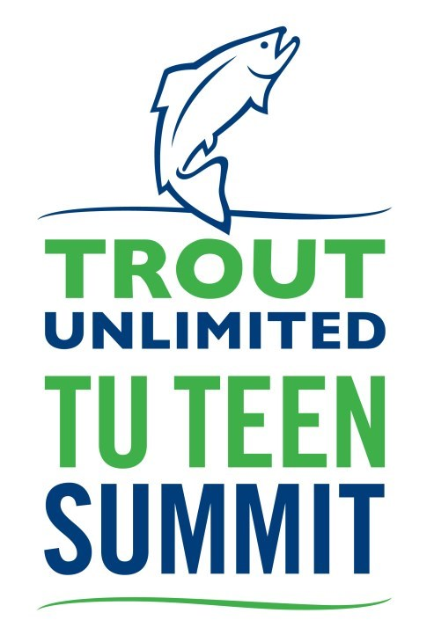Come to TU’s Teen Summit National Leadership Conference to meet other TU teens from across the country, talk about how TU can better engage teen members, learn how to become a TU leader in your community, work on a service project, and fish! Spend three full days in the birthplace of Trout Unlimited with a group of new friends that love fishing, the outdoors and TU as much as you do.

Where: | Camp Westminster on Higgins Lake in Roscommon, MI
When: | Sunday July 26– Thursday July 30, 2020
Who: | Dedicated anglers and conservationists who have shown involvement with TU and have just completed 8th, 9th, 10th, or 11th grade. Application is required and not all teens are accepted to attend. All summiteers must be TU members before attending the TU Teen Summit; teens sign up for $14 at www.tu.org/youth.
Cost: | $350 includes food, lodging, and shuttle from the airport. Selected applicants will be asked to pay this fee by mid-May.
To apply: Application available on www.tu.org/teensummit. Deadline is March 13, 2020 at midnight. Some applicants will be invited to participate in a phone interview.
Activities include:
- conservation and fishing tours of the Au Sable and surrounding rivers
- leadership skills workshops to bring TU activities into your community
- conservation and science sessions
- fly tying and fly fishing workshops
- fly fishing and conservation biology guest speakers
- a service project at a local stream
- time for hanging out by the campfire, tying flies, and fishing!

