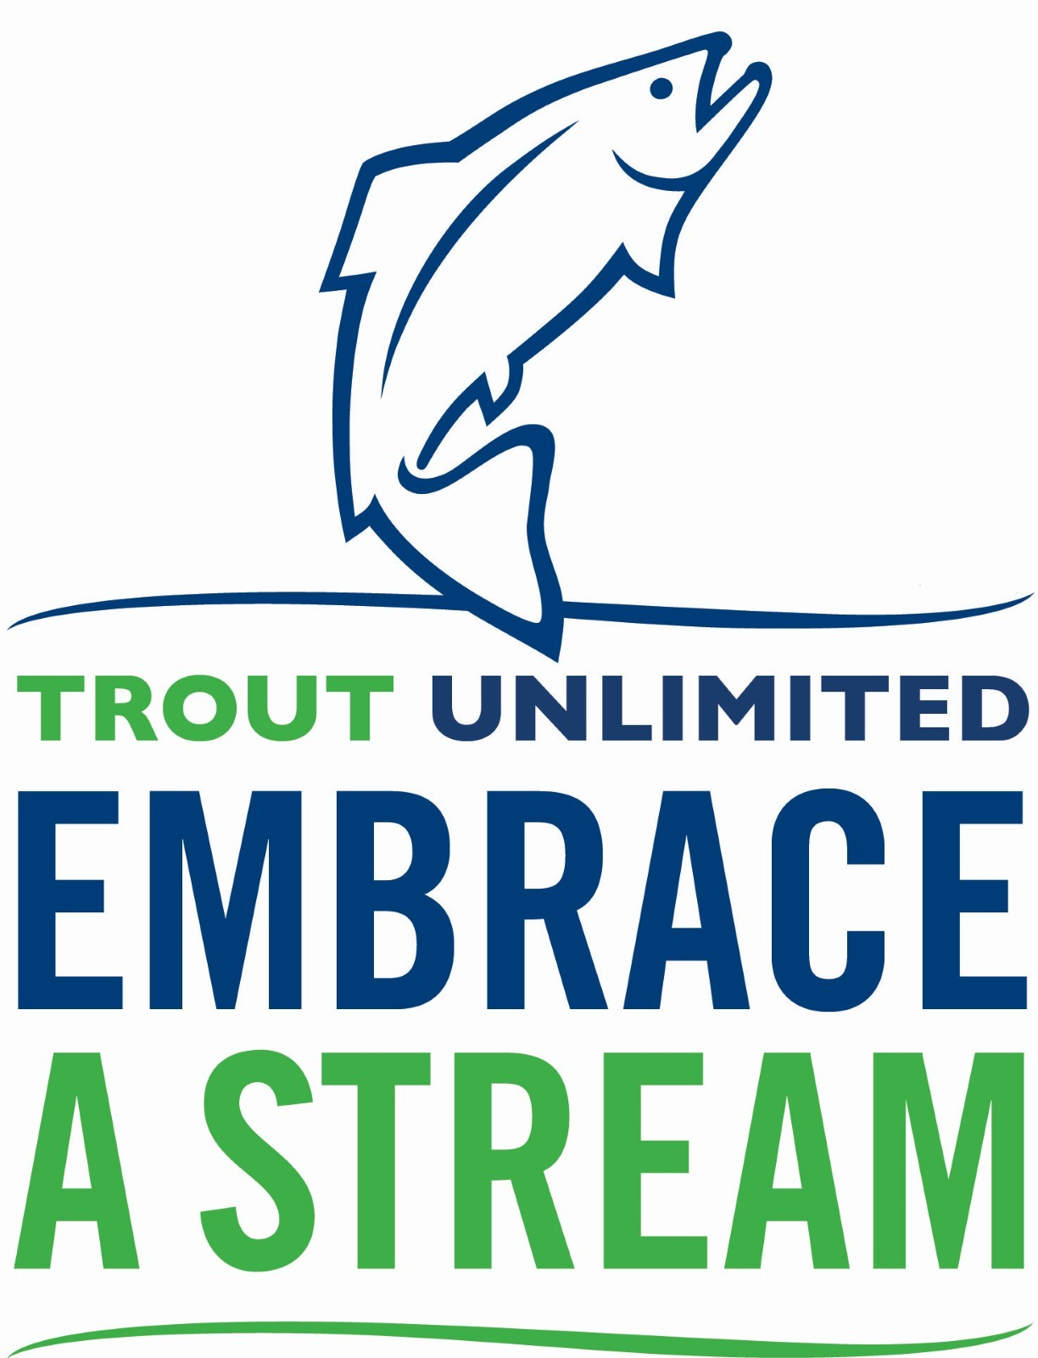

Embrace A Stream DRAFT Grant Application
Use this draft template to write your grant application draft and share it with your Embrace A Stream representative before submitting a final application. Be sure to adhere to word count requests where applicable. NOTE: The final application should be submitted through the online form.

Provide Your Basic Information

1. Chapter Number & Name (Example: 123 - Smith Creek Chapter)

2. State

3. First Name

4. Last Name

5. Email Address

6. Phone Number

7. Chapter Volunteer Role

8. Project Title

9. Project Location (stream, watershed, GPS coordinates if possible)

10. Salmonid Species Impacted and Threatened/Endangered Status (if applicable)

11. Please indicate which conservation strategy your project best fits:
- Protect (Public lands policy, land trust partnerships, defense from development etc…)
- Reconnect (Barrier to fish passage removal, in-stream flow enhancement etc…)
- Restore (Watershed and habitat restoration projects, policy to provide restoration incentives and funding etc…)
- Sustain (Community science and monitoring efforts, youth education programming, community engagement activities etc…)

12. Amount Requested from Embrace A Stream

13. Project Timeline
Anticipated Start Date
Anticipated Completion Date

14. Has chapter received EAS funds before?
Yes
No

Executive Summary
15. In 300 words or less, please note the project name and location, name of the applicant to chapter or council, amount requested, matching funds available, background or purpose of the project, goals and objectives, proposed actions or methods, anticipated scope of impact, and partners. The executive summary should be brief and to the point. The EAS committee will refer to it frequently during the review process.

Background
16. In 1000 words or less, describe the issue or opportunity being addressed. If applicable describe project location, including name of water body and salmonid species. Please show how this issue or opportunity has other regional or national significance. If the project is part of a TU national initiative, please explain the extent of coordination with TU national staff. If this project has received EAS funding in previous years, please provide a brief update on progress to date.

Goals & Objectives
17. In 350 words or less, briefly describe the purpose of the project, resulting benefits for cold water conservation and the TU organization, including scope of impact. Also describe any economic benefits that will result from your work. Please also note:
- The overall goal of the project (e.g. restore critical habitat for a certain species of endangered salmonid, build a local constituency to promote protection of a certain resource, improve the scientific understanding of an issue to improve river or fishery management etc..)
- List the specific conservation objectives for the project (e.g. restore X amount of habitat by Y method, educate X number of people through Y means, fill X information gap through Y research methods, influence local or state governing body to adopt X policy/law to protect Y habitat or fish etc…)
- List the specific TU strengthening objective for the project (e.g. recruit X new leaders or members by method Y, develop an actionable plan for a conservation campaign, increase TU coverage in local media by X% etc…)

Work Plan
18. In 500 words or less, describe the actions or methods you will use to implement your proposal. Make sure to include plans for implementing both the conservation and strengthening TU objectives. If applicable explain the scientific or technical methods utilized in the project. Note if the project uses innovative or unique solutions to address fisheries problems or if the results can be transferred elsewhere. Please also include:
- A timeframe or schedule of when major activities will occur, including a list of any permits that will be obtained.
- The role of TU leaders, volunteers, or staff in the project and the names and qualifications of key participants. EAS projects require TU volunteers have significant involvement.
- An outreach plan to disseminate project results to TU, project partners, and especially the general public.
- A description of how you will measure or evaluate project outcomes. Explain the scientific or technical methods used to evaluate project results, including the indicators (an indicator is a specific, measurable target or goal) for project success. Grant recipients will be required to evaluate the outcomes of their projects by measuring these indicators before and after their project.

Communications Plan
19. List at least 3 local media outlets you will contact (print, tv, radio online, social)
20. In 500 words or less, provide a brief outline for how the applicant will broadcast information about the project and EAS awards to their local community. A robust communications plan will include press releases, social media posts, website updates, project location signage (temporary and permanent) and more. We ask that successful applicants submit no fewer than two updates through the course of the EAS funded project to TU suitable for sharing in our social media and emails.
21. In 500 words or less, provide a brief description of community awareness and education events the chapter will host at the project site or related to the project. Examples of community awareness and engagement events include:
- A public site visit before and/or after construction
- A Zoom program with partners inviting the public to learn more about the work and the resource being restored
- PowerPoint presentations made to local civic organizations such as garden clubs, land trusts, Kiwanis, Rotary, Lions and others etc...

Budget
The budget is intended to assist applicants in writing project budgets and explaining project costs. Applicants are required to indicate total project costs, as well as EAS costs and non-EAS expenses. Please be as specific as possible when describing your project expenses and keep in mind that there must be a one-to-one match to qualify for an EAS grant. EAS looks favorably upon cash contributions from the chapter and other partnering organizations, as well as projects with high expected returns to justify the cost of the project.
Total project costs can be defined in terms of cash gifts, personnel and cost of materials and services. Applicants must identify all other contributors and indicate the type and amount of matched costs (e.g. $500 grant, US Forest Service). Estimates of direct cash costs and in-kind contributions to EAS must be specified in the categories below.
Personnel/consultant fees - Outline specific tasks, work to be performed by personnel/consultants and the basis for their fees. Total fees should be broken down according to the amount of time spent on the project e(e.g. hourly, weekly or monthly rates). Trainers and facilitators are allowable expenditures. Sponsoring professionals cannot be persons receiving money directly from an EAS grant.
Volunteer labor - Identify all sources of volunteer labor both TU and non to U. Donated professional services can be valued at current market rates general volunteer labor may be valued according to the most recent determination of the value of volunteer time by independent sector as of 2021 this is $28.54 per hour.
Contracts - Identify all work to be completed by contract. If a commitment to contractor particular vendor has been made prior to application for funding, explain how the vendor was selected, type of contract, deliverables, timeframe, cost, and basis for the cost.
Materials / Equipment – Please specify unit cost and quantities for materials and equipment. Identify specific materials and equipment necessary to complete the project. Costs are to be estimated according to the average market value of the equipment. Consumable office supplies may be included under the equipment category. Purchasing high-cost capital equipment (e.g. chainsaws, waders etc…) is highly discouraged - rental of such items should be considered instead. Equipment for on-going stream and watershed monitoring projects will be considered given adequate justification of their need and lack of ready availability. EAS does not fund computer equipment, software, newsletters, or websites, unless given compelling rationale for how such tools are linked to the conservation objectives.
Other Expenses - Identify any other specific costs associated with the project. Please note that transportation costs for volunteer labor (e.g. lodging, mileage and gas expense) are not eligible for EAS funding. Travel may be counted as match at $0.585 per mile.

Document Uploads

22. Upload Your EAS Budget (Budget template available at www.tu.org/eas - be sure to save your final budget as a PDF before uploading.)

23. Letters of Support (Upload all letters of support as one merged PDF file. At the LEAST you MUST have a letter of support from the chapter president, council chair and landowner of the property where the work is taking place. Chapters are encouraged to have letters of support from partner organizations, state and local agency partners and TU staff involved in the project.)

24. Supporting Documents (Upload all supporting documents as one combined PDF file. These may include site images and descriptions, final or conceptual project plans etc...)

