STREAM Keepers

The
Volunteer Guide
An exploration of your watershed!
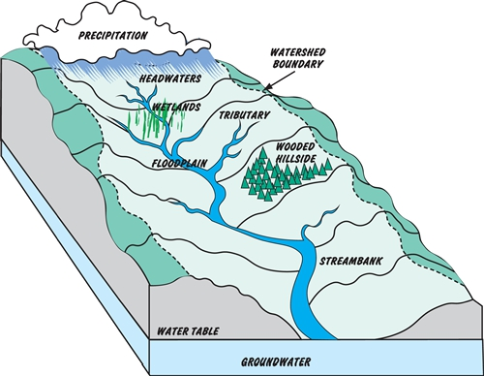

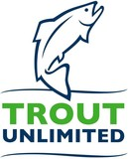
STREAM Keepers Volunteer Guide

A guide for TU Volunteers

Trout Unlimited is excited to offer this curriculum for exploration of a local stream.

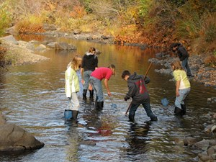

Every person is a citizen of their watershed, and we would like to share what that means to TU. By visiting a local stream and having the opportunity to observe it as scientists, anglers, and artists, both children and adults will get the complete picture of what their stream could mean to them.

Over the course of multiple sessions, you will lead participants in observing a stream, sampling macroinvertebrates, fly tying, and fly casting. Each day also includes time to explore the natural area and record thoughts and observations in field notebooks.

This program was originally developed as STREAM Girls in partnership with volunteers of the Wisconsin Council of TU and the Girl Scouts of the Northwestern Great Lakes Council.

Table of Contents

Introduction to STREAM Education
- About this guide
- Notes on Reflection
- Repeated Units: Methods for Gathering, Reflection, Sharing.
- Sessions overview
Session One: Welcome activities and STREAM Walk Session Two: Fly casting
Session Three: Go with the Flow!
Session Four: Macroinvertebrate sampling Session Five: Fly tying
Session Six: Stream Scavenger Hunt, Bracelets / Pins Closing Ceremony
- Choosing a Location
- Get Ready, Set, and Go!

Appendix

- Sample Schedule
- STREAM Keepers resources on-line
- STREAM Walk tips
- Stream flow worksheet
- Fly casting details
- Macroinvertebrate sampling techniques
- Macroinvertebrate data sheet
- Leave No Trace principles
- Free time ideas
- Other resources / Suppliers list

  - What is STREAM education?

STEM Education:
You may be familiar with the phrase “STEM” education, which refers to learning in Science, Technology, Engineering, and Math.

STEAM Education:
You may also have heard of “STEAM” education, which includes the Arts in addition to STEM (fly tying, creative writing, and sketching!).

STREAM Education:
At TU, we believe in “STREAM” education, which includes all the above topics, plus
Recreation (fishing!).

Here are two examples of how activities in this guide all together make up a STREAM education experience:
1. STREAM WALK

A thorough observation of a section of stream.

Taking the Artist’s Approach:
Conduct a multi-sensory observation of the stream. Search for various elements of the ecosystem including the water, plants, animals, weather, soil, rocks, and landscape. Record findings and discuss different ways in which the different elements of the ecosystem interact.

Taking the Scientist’s Approach:
Participants follow citizen science protocols to measure the condition of a stream. This includes evaluating the stream bank, water flows, ecosystem biodiversity, stream bed, and possibly water chemistry. They record their findings and discuss what impact humans may be having on the stream.

Taking the Angler’s Approach:
As the participants observe and assess the stream as scientists and artists, they will also discuss what makes the stream most hospitable for fish, and point out likely places where fish are hiding.

2. MACROINVERTEBRATE SAMPLING

A close-up look at stream animal life

Looking through an Artist’s Eye:
Discover stream bugs through investigating natural leaf packs or turning over rocks. The participants discuss the full life cycle of these bugs and spend time closely observing and sketching the animals.

Looking through a Scientist’s Eye:
Follow citizen science protocol to assess long-term water quality. This includes a thorough seine or kick-net sampling of the stream’s macroinvertebrate life and classification and recording of the organisms found. They will be able to tally their findings to give their stream an overall water quality score.

Looking through an Angler’s Eye:
After a full macroinvertebrate collection, the participants consider the bugs as “fish food.” This discussion leads right into fly-tying and the philosophy and creation of fishing flies (suggested next activity).

As you go through each activity, you may want to ask what elements of STREAM the participants are employing:
    - What science practices, concepts, and ideas are they learning and using?
    - What technology are they using? How does it help make the work easier?
    - How are they becoming better anglers, or enjoying outdoor recreation?
    - What has been engineered here? Anything through green engineering?
    - What art are they inspired to write, create, or perform?
    - What kind of math is necessary to answer the questions they have?

II. About this Guide

Each Session includes the following units:

While the participants are gathering
    - Introduction to the activity
    - The main activity
    - Reflection
    - Sharing and closing
Core Activities: Eight core activities make a STREAM Keepers program. You may choose activities that fit the interest and timeframe for your event.

The eight core activities are (by suggested sequence):
- STREAM Walk
- Fly casting
- Go with the Flow!
- Macroinvertebrate survey
- Fly tying
- Stream Scavenger Hunt and Bracelets
- Some amount of reflection throughout
- Some amount of discussion throughout
Again, this is the suggested sequence of the program, but you can do the activities in any order. Feel free to do what is best for your local weather, waters, and volunteer availability.
Scheduling: This guide was developed based around a weekend format for STREAM Keepers. See Appendix A for a sample schedule. It could also be done as an afterschool or evening program by completing one session each day.
A ballpark time allotment is noted for each activity. These times are just a guide, and you should run the activities in a way that makes sense for your stream, volunteers, and participants. Especially, please do not cut short a thought-provoking discussion or engrossing field exploration—let the learning take all the time it needs.

Additional activities: You may also expand and add other activities such as other nature hikes, art projects, water chemistry testing, soil testing, birding, etc.

III. Notes on Reflection

Reflection and discussion are important parts of each participant’s learning and knowledge retention through the STREAM Keepers experience.
Participants use reflection and discussion to:

    - Remember and think about what was experienced.
    - Relate to current and prior experiences.
    - Represent the experience by actively participating in learning.
    - Reach further into the experience by extending thinking to higher cognitive levels.
    - Revisit the experience by looking at the value of the experience and exploring what else can be learned from it.
REMEMBER: In the reflective process, STREAM Keepers think about what they have experienced, analyze information, examine their values after their experience, and apply what they have learned to future experiences.

Repeated Units: Gathering, Reflection, and Sharing

Please follow these instructions for the “While the Participants are Gathering” unit of Sessions 1, 2, 4, and 5 (Sessions 3 and 5 do not have assigned pre-activity writing prompts):
  - Welcome each participant upon arrival. Introduce yourself and make sure that your nametag is clearly visible. Invite participants to make their own nametag.
  - If not done already, hand each participant a copy of the field notebook and ask that they write her name on the front or back cover. Invite participants to respond to the prompts related to each section while you wait for all of the participants to arrive.
  - Participants who finish this prompt may want to talk to other participants, or to volunteers. This is a time to be friendly and welcoming, making each participant feel comfortable and included.
At the end of each session, use this method for the “Reflection” unit of the session using the pages listed for that session:
- Tell the participants that this is a time for them to reflect on what they’ve learned and to write or draw that in their handbooks. Remind them that poetry is another way to capture their thoughts.
- Invite them to respond to the prompts on related to each section if they have time.
- Be sure to warn the participants when they have 5 minutes left, and 1 minute left, so that they can finish up their work.
For the final part of each session, use this method for the “Sharing” portion, if there is time:
- Invite the participants to share what they’ve written or drawn in their handbooks.
- Invite a few volunteers to share their reflections on what THEY have learned.
- Talk a little bit about the importance of what you’ve learned that day and ask some questions. For example:
-Did you learn something new or clarify an interest?
-What happened? What did you observe?
-What did you like/dislike about the experience?
- Did you hear, smell, or feel anything that surprised you?
-What seems to be the root cause of any environmental issues?
-How can you apply this learning?

Sessions Overview

Session One: Welcome activities and STREAM Walk
  - While participants are gathering (pages 2-3)
  - Welcome, introductions, and Stream Team formation
  - Introduction to STREAM Walk
  - STREAM Walk (pages 4-13)
  - STREAM Walk follow-up and reflection (pages 14-17, 32-33)
  - Sharing and closing

Session Two: Fly Casting
  - While the participants are gathering (pages 28-29)
  - Introduction to fly casting
  - Casting practice and instruction
  - Reflection (pages 24-25)
  - Sharing and closing

Session Three: Go with the Flow!

  - While the participants are gathering (no assigned writing prompt)
  - Introduction to Go with Flow!
  - Flow measurement exercise (pages 18-19)
  - Sharing of findings and conclusions
  - Sharing and closing

Session Four: Macroinvertebrate Sampling
  - While the participants are gathering (pages 30-31)
  - Introduction to Macroinvertebrate sampling
  - Macroinvertebrate sampling (pages 20-21)
  - Findings and conclusions (pages 22-23)
  - Reflection (page 34)
  - Sharing and closing

Session Five: Fly Tying
  - While the participants are gathering (free form reflection pages 36-37)
  - Introduction to fly-tying and one realistic fly
  - Fly tying extravaganza!
o Reflection (pages 26-27)
o Sharing and closing

Session Six: Stream Scavenger Hunt and Bracelets
  - While the participants are gathering (no assigned writing prompts)
  - Introduction to Stream Scavenger Hunt
  - Stream Scavenger Hunt (pages 38-47)
  - Teams share their scavenger hunt findings
  - STREAM Participants bracelet or pin
  - Sharing and closing
  - Final reflection (page 48)

Choosing a location

Water activities: Choose a location where water is easily accessible. You should be able to walk along or in the stream to make observations, conduct a macroinvertebrate survey, and if there is time, a fishing locale. Choose a fishing locale appropriate for beginners. A bass or panfish pond with poppers works great.
Other activities: An open, grassy area for casting. Indoor or covered areas for fly tying and art activities. Bathrooms!

Get Ready, Set, And Go!

All of the resources you’ll need, including this guide and other resources not referenced here, can be found digitally, online at www.tu.org/streamgirls.

Tips on preparedness:
- Reference the Check List at www.tu.org/streamgirls
- Preview the area where you will do the STREAM Walk and run through activities
- Have equipment bundled per activity in totes or bins

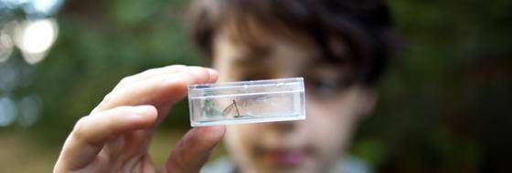

Core Activities of the

STREAM Keepers program

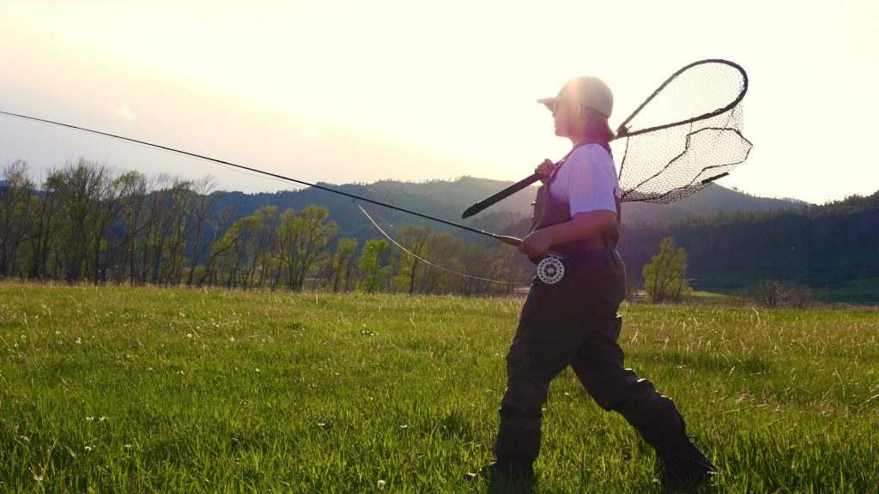
- Welcome and STREAM Walk

Approx. time: 3.5 hours
Session One: While participants gather
Time: flexible
Handbook: pages 2-3
Objectives: To gather the whole group and get the participants ready to learn. Supplies: nametags, markers, handbooks, pens/pencils, colored pencils
Session One: Welcome, introductions, team formation,

Time: 40 minutes
Objective: To engage every participant and start building community. Supplies: handbooks, pens/pencils

  - Gather everyone (TU volunteers and participants) in a circle.
  - Say that you’ll ask everyone to say their name and one thing they’re looking forward to about STREAM Keepers. Start with yourself and go around.
  - Once the introductions are complete, take the time to:
    - Explain who your local chapter/council is, and who TU is.
    - Go over any ground rules or guidelines, and facilities notes (like where the bathroom is, or plants to avoid).
    - Cover expectations for the day, such as being involved and trying every activity. Give a general overview of the day’s schedule, so that the participants know what to expect.
  - Once guidelines and expectations are complete, ask the participants to count off into the number of stream teams you plan to have (skip any adults in the circle). As a guideline, your stream teams should have at least 4 and no more than 8 members. This ensures that
every participant gets the opportunity to do many things hands-on over the course of the program.

Session One: STREAM Walk Time: 100 minutes
Objective: To deeply observe all aspects of a stream. Handbook: pages 4-13
Supplies: handbook, pens/pencil, clipboard or cardboard to lean on, gallon-size plastic zipper bag (if it’s raining)
- Have the participants gather by number along with at least one of the volunteers that they’ll be working with that day on the stream. The participants should decide on a team name - encourage them to make it stream-related. Share your names with the group.
- Clearly state which section of stream each team is visiting and be clear with the volunteers about what time to report back. Be sure all the adults know what the plan is in case of various types of emergencies.
- Each team should work together to answer pages 4-13 of their handbooks, with each participant writing down every answer that the team comes up with. Page 4 can be done as a whole group or in teams.
- See Appendix C for more tips and guidelines.

Session One: STREAM Walk Reflection Time: 15 minutes
Objective: To give the participants an opportunity to capture what they’ve learned. Handbook: pages 14-17, 32-33
Supplies: handbooks, pens/pencils, colored pencils
See 5. Repeated Units section for instructions.

Session One: Sharing, discussion Time: 15 minutes
Objective: To give participants the opportunity to share what they’ve learned. Handbook: pages 14-17
Supplies: handbooks, active listening ears

See 5. Repeated Units section for instructions.

Fly-Casting

Approx. time: 1.5 hours
NOTE: Session Two can be done simultaneously with Session Three (Go with the Flow!). Split the group in half and switch after around 45 minutes.

Session Two: While the participants gather Time: flexible
Handbook: pages 28-29
Objectives: To gather the whole group and get the participants ready to learn. Supplies: nametags, markers, handbooks, pens/pencils, colored pencils

Session Two: Introduction to fly casting and practice Time: 45 minutes
Objective: To learn the basic mechanics of fly casting.
Supplies: a yarn rod for every participant (optional), real rods for every participant (with pipe cleaner instead of a fly/hook), hula hoops for targets, hats for every participant, eye protection. See Appendix E for more detailed instructions.
  - Start by going over the parts of a fly rod, including the fly reel and fly line.

  - Explain the difference between a regular spinning rod and a fly rod.
  - Give a basic lesson on how and why a fly rod works, how it acts as a lever to cast line.
  - Demonstrate a basic overhead cast, stressing arm position and where to stop the rod. Teach Snap-Pause-Snap
  - Demonstrate a basic roll cast, stressing arm position and where to stop the rod.
  - Have participants work in pairs with office yarn rods (if you have them). One participant observes the other and provides feedback on casting participant’s form, then they switch.
  - Volunteers walk from pair to pair during the casting to make adjustments and provide feedback.
Session Two: Reflection Time: 15 minutes
Objective: To give the participants an opportunity to capture what they’ve learned. Handbook: pages 24-25
Supplies: handbooks, pens/pencils, colored pencils

Go with the Flow!

Approx. time: 1.5 hours
Session Three: Go with the Flow!

NOTE: Session Three can be done simultaneously with Session Two (Fly casting). Split the group in half and switch at an agreed upon time.

Time: 60 minutes
Handbook: pages 18-19
Objectives: To calculate the flow of the stream.
Supplies: handbooks, clipboards, pencils, 4 ping pong balls, stop watch or timer, survey flags or similar indicators, yard stick (depth), measuring tape (distance).
  - Gather streamside.
  - Start by asking the participants what flow means (the movement of water – how much and how fast). Talk about what flow is (velocity multiplied by area to equal cubic feet per second). Explain that humans can impact how a stream responds to precipitation. For example, land use around the stream, such as over-grazing by animals and removal of riparian areas, will increase surface runoff because the natural filter (plants) are gone which can cause a high increase in water and even lead to flooding. Conversely, if humans are using or pumping water from the stream, a decrease in flow can cause higher water temperatures which results in low levels of oxygen which can harm insect or fish populations. Changes in flow are also a natural result of weather patterns.
  - Explain how teams will measure flow of their given stream. Break participants up into two teams (or whatever number works best, just be sure you have enough instruments).
  - Work with both teams to complete stream flow worksheet (Appendix D). Have each team member take turns measuring, capturing, and calculating data.
  - When teams have completed sheet, bring group together and compare results.
  - Discuss role of data collection in scientific studies. (For example, how does USGS use flow data?)

Macroinvertebrate Sampling

Approx. time 2.5 hours
Session Four: While the participants gather Time: flexible
Handbook: pages 30-31
Objectives: To gather the whole group and get the participants ready to learn. Supplies: nametags, markers, handbooks, pens/pencils, colored pencils

Session Four: Macroinvertebrate sampling

Time: 60 minutes
Handbook: pages 20-23
Objectives: To discover the invertebrate life of a stream and to measure the abundance and diversity of this life as a sign of long-term water quality.
Supplies:
For each participant: handbook, pens/pencil, clipboard or cardboard to lean on, gallon-size plastic zipper bag (if it’s raining), macroinvertebrate keys (link in Appendix F), macroinvertebrate data sheet (Appendix G)
For each team: seine or kick net, tubs or buckets, sorting dishes or ice cube trays, plastic spoons, hand lenses or jeweler’s loupes, some boots

  - Introduce aquatic macroinvertebrates. Introduce the word and ask the participants to say it a few times with you. Talk, in general, about what macroinvertebrates are and what each part of the word means.
  - Explain that these organisms live in streams, and that you’ll be taking a while to study them today. Be clear about which section of stream each team is going to, whether they are separate or whether you’re working in one large group.

  - Once streamside, start by completing page 20 of the handbook. Then involve the participants in kicking up the sample, gathering leaf packs, and turning over rocks, gently collecting swimming organisms, etc.
  - Then, have each team work on sorting a collection of macroinvertebrates, separating the orders from one another (gently) using the plastic spoons and putting them in the sorting trays/dishes.
  - Throughout, and together, work on pages 21-23 of the handbook.
  - See Appendix F for more guidelines and suggestions.

Session Four: Findings and conclusions

Time: 15 minutes
Handbook: pages 21-23
Objective: To compare findings and synthesize data to reach conclusions. Supplies: handbooks

Session Four: Reflection

Time: 15 minutes
Objective: To give the participants an opportunity to capture what they’ve learned. Handbook: pages 34
Supplies: handbooks, pens/pencils, colored pencils

Session Four: Sharing and discussion
Time: 15 minutes
Objective: To give the participants an opportunity to capture what they’ve learned.
Supplies: handbooks, active listening ears

Fly Tying

Approx. time 2.5 hours
Session Five: While the participants gather Time: flexible
Handbook: pages 36-37 (blank pages, free form)
Objectives: To gather the whole group and get the participants ready to learn. Supplies: nametags, markers, handbooks, pens/pencils, colored pencils
Session Five: Introduction to fly tying and one realistic fly Time: 60 minutes (or longer)
Objective: To introduce the participants to flies and basic tying techniques. Supplies: A fly tying setup for every participant, or for every 2 participants if they are young children; macroinvertebrate keys
  - Start the discussion by asking what the participants already know about flies and fly tying. Have them recall what macroinvertebrates they found in and near the stream at your program site.
  - Be sure to share pictures and illustrations of the actual macroinvertebrates that the flies you have are imitating.
  - Introduce and tie step-by-step an easy but fun fly, such as a woolly bugger.

Session Five: Fly tying extravaganza!
Time: 45 minutes (or longer)
Objective: To give the participants space to use their creativity and imagination. Supplies: A fly-tying setup for every participant, lots of brightly-colored tying materials

- Set the participants free on a fly-tying extravaganza, where the only limit is their imagination.

- Some participants will want to tie brightly-colored woolly buggers, and that should be encouraged. Other participants will want to learn other realistic flies from the volunteers on- hand; that should be encouraged, too. Please support participants as they direct their own progress.
- Be sure to give 5-minute and 1-minute warnings before clean-up begins. (Or put off clean-up until the end of the day.)
- Leave one fly-tying set-up in place, to be referenced again after break.

Session Five: Reflection Time: 10 minutes
Objective: To give the participants an opportunity to capture what they’ve learned. Handbook: pages 26-27
Supplies: handbooks, pens/pencils, colored pencils, one fly-tying set-up left in place for the participants to reference for their sketches.

Session Five: Sharing and closing Time: 10 minutes
Objective: To give participants the opportunity to share what they’ve learned. Handbook: pages 26-27
Supplies: handbooks, active listening ears

STREAM Scavenger Hunt and Bracelets

Approx. time 1.5 to 2 hours
Session Six: While the participants gather Time: flexible
Objectives: To gather the whole group and get the participants ready to learn. Supplies: nametags, markers, handbooks, pens/pencils, colored pencils
Session Six: STREAM Scavenger Hunt Time: 60 minutes
Handbook: pages 38 - 47
Objective: To introduce the idea that healthy streams have many parts
Supplies: handbooks, 2 sets of 9 survey flags labeled 1 through 9 with a marker
  - Gather the entire group together, and explain that many parts come together to make a healthy stream.
  - Read the nine “ingredients” of a stream together as a group (page 38)
  - Break the group into stream teams and give each team one set of nine survey flags.
  - The purpose of the scavenger hunt is for members of each stream team to explore the stream and riparian area and find a good example of each stream ingredient. Teams flag their representative ingredient and are to discuss their selections and use consensus to arrive at their final nine.
Flag #1 Water
Flag #2 Riffles
Flag #3 Rocks
Flag #4 Trees
Flag #5 Wood
Flag #6 Short plants

Flag #7 Sky
Flag #8 Animals
Flag #9 Bugs
  - When finished, each stream team presents their stations to leaders, volunteers, and/or other group and explains why that area represents the ingredient they chose.
Session Six: Bracelets / Pins

Time: 30 minutes
Objective: To reflect on what the scouts just learned and to create a keepsake that reminds them of a healthy stream.
Handbook: reference page 38 for ingredients
Supplies: used fly line or thin cord cut into bracelet lengths, or large safety pins for making jewelry (no coil), 9 different beads as follows:
(see Appendix J for specific bead retailer):
WATER – clear bead
RIFFLES – frosty or bubbly bead
ROCKS – rock or crackled earth-tone bead TREES – dark green bead
WOOD – wooden or brown bead SHORT PLANTS – light green bead SKY – sky blue bead
ANIMALS – feather charm BUGS – dragonfly charm

    - Gather the entire group together and explain the purpose of the STREAM Keepers bracelet or pin is to capture all nine healthy stream ingredients in a memorable, wearable way.
    - Each participant is given a piece of fly line, cord, or pin on which to put the beads.
    - As beads are presented, participants understand what part of a healthy stream it represents.
    - Hand out all nine beads and assist participants with making their bracelet or pin.

Closing ceremony

Approx. time 0.5 hours
Final Session
Time: 30 minutes
Objective: To celebrate being STREAM Keepers
Supplies: patches/t-shirts/certificates or whatever you’re giving the participants in recognition of their learning and hard work

- Gather everyone together and announce that it is time to celebrate all that you have learned and accomplished together as STREAM Keepers.
- Call names and distribute STREAM Keepers certificates. You may want to have a high-five line of TU volunteers for the participants to run by after they receive their reward.
- Photos, photos, photos
- Invite participants to make any closing remarks, and make any closing remarks from a TU perspective.

Final Session: Reflection (optional)
Time: 5-10 minutes
Handbook: page 48

Objective: To finish the with a poetic reflection of what STREAM means to the participants.
  - Ask the participants to write an acrostic poem to the word STREAM. An acrostic poem is a type of poetry where the first, last or other letters in a line spell out a particular word.

Optional (extra) Activities

These can be good rainy day activities or fill blocks of time for longer weekends.
Drawing a stream

Time: 30 minutes
Objective: To capture what they’ve learned and view the stream as an artist. Supplies: pens/pencils, clipboard or cardboard to lean on, gallon-size plastic zipper bag (if it’s raining), paper, colored pencils/crayons/pastels/watercolor

    - Start by asking a few participants to share something surprising or interesting they learned on their Streamwalk.
    - Explain that we’re now going to ask the participants to view the stream as artists, but to remember what they learned as scientists. They will have 25 minutes to draw the stream, and they should make an artistic drawing, but they should also include all 9 stream “ingredients” in their illustration.
    - Define the parameters of where the participants can go to draw—be sure to encourage them to sit or stand near the stream for inspiration. Announce how you will call the group back at the end of the drawing time.
    - Distribute art supplies and encourage the participants to spread out and work independently.
    - For participants who “finish” early, encourage them to add details, textures, colors, etc. to their work. Participants can also label their pictures, to make them more like scientific illustrations. Some participants may also want to make drawings of some of the details they see around, such as certain plants, animals, or rocks. If the macroinvertebrates are still out, some participants may want to spend more time with them. Give the participants a 5-minute warning, if possible, before you call them back.
    - Once the group has gathered, have a “floating art gallery.” Have half of the participants hold up their art, while adults and the other participants silently walk among the pictures, looking closely at them. Then switch, so the participants get the opportunity to play the other role.

Postcards from the watershed

Time: 25 minutes
Objective: To give the participants an opportunity to reflect on their experience and to share their learning with family at home.
Supplies: blank postcards (or 8.5” x 11” cardstock cut into four pieces), art supplies such as markers or colored pencils, pens/pencils, addresses for family, postcard stamps

Postcards provide a tool for capturing the information that participants have gained during STREAM Keepers field day and sharing it with friends. The postcards can be preserved as a reminder of the experiences exploring home waters, and learning a new life sport.

Having the participants address at least one postcard to their own homes is an important aspect of this activity. When you mail the postcard from near the stream site, it will arrive at their homes a few days later, and it may prompt renewed conversations with family and friends.

- After walking the stream, casting, and spending some time in nature, participants will create a postcard influenced by their experience and the outdoors. Participants can paint or draw a landscape, trace or make a print of a natural object they have found or design the postcard in any way.
- Gather the participants and explain the activity. Encourage them to illustrate and write messages that describe what they’ve been learning as STREAM Keepers.
- Ask participants to write a small paragraph about their experiences throughout the day and fill in the appropriate "to" and "from" addresses
- Add a postcard stamp and mail from a mailbox or post office near your stream site.
- In small groups or as a troop, have the participants summarize what they wrote home and how they think their families will react to the note.

Appendix

Appendix A: Sample Schedule

 | Saturday | Notes
8:30-10:00 | SET UP
10:00-10:30 | Arrival & Check-in
10:30-11:30 | Welcome, nametags, handbooks.  Pre-Evaluation. Icebreaker/name game Intro and Overview Team Formation | Location:  Handbook: pages 2-3  -what does STREAM Keepers stand for?  -ground rules, troop leaders?  -everyone being involved makes the teams
11:30 – 12:15 PM | Lunch | Be sure participants are wearing clothes and shoes they can  get wet!
12:15 – 12:30 | Walk to stream
12:30–2:15 | Streamwalk Leaders | Location:  Handbook: pages 4-13  - Help answer questions, have fun with the participants.  - Be sure to get through all of the pages!
2:15 – 2:35 | Reflection | Location: nearby the stream  Handbook: pages 14 -17, 30-32
2:35 – 2:50 | Snack & free time | Begin set-up for casting lesson in field & Go with the Flow! activity
2:50 – 3:30 | Reflection/discussion | Discussion – have the participants tell us some of their most interesting observations.  Handbook: pages 14-17, 30-32
3:30 – 6:00 | Fly Casting 101 Leaders: | Location: field area  - Go over equipment  - Talk about difference between spin cast, why we do it, then a hands-on lesson
3:30 – 6:00 | Go with the Flow! | Handbook: pages 18-19  Worksheets, measuring devices, etc.
6:00 -7:00 | Dinner
7:00 – 9:00 | Fishing

 | Sunday | Notes
8-8:30 AM | Breakfast
8:30-9:00 | Introduction + review schedule
9:00-10:30 | Macroinvertebrate sampling (stream health) Leaders: | Handbook: pages 20-23
10:30 – 10:50 | Break & Reflection | Handbook: pages 34-36 (reflect on macro survey)
10:50- 12:00 PM | Intro to Fly tying Leaders: | Location:  Volunteers:  Describe fly tying, what it is, why we do it. How it directly relates to the macroinvertebrate survey we just did (food chain, phenology).  - Tie wooly bugger
12:00 – 12:30 | Lunch | Location:
12:30-2:00 | STREAM Scavenger Hunt and Bracelets / Pins | Handbook: pgs 38-47
2:00 – 2:15 | Post eval, pledge, certificate, patches
2:30– 4:00ish | Fishing | Everyone drives themselves and we leave from the fishing area.

Note: Another format that works well is to do fly tying in the evening as the last activity of the day, especially if overnight. This allows the participants to spend a couple of hours creating their own flies while using their creativity and tying skills and being social.

Appendix B: Visit www.tu.org/streamgirls for downloadable versions of STREAM Keepers documents!

Appendix C: Streamwalk tips from EPA

- It is recommended that you use public access points (such as city/county/state parks and campgrounds). Get the permission of landowners to cross any private land, posted or not. Do not enter areas without permission.
- Only record what you see, not what you have previously seen. For example, if you think fish are present but you can’t see them, mark your sheet “no fish present.”
- Do not put yourself in danger to gather survey information.
- Be careful of ticks, poison oak, nettles, parsnip, and insects. Bring repellent. Wear long pants, boots, and long sleeves.
- Watch out for dogs, snakes, alligators, and large animals.
- Do not walk on unstable banks; your footsteps could speed erosion.
- Be alert for spawning areas (redds) in the stream. Do not walk on them. They will look like a round or elliptical area of clean gravel about 1–3 feet long.
- In the summer, if you are careful, the streambed might be the easiest route for conducting your Streamwalk. Be aware that the streambed can be very slippery, uneven, and unpredictable.
- Be careful of streamside vegetation. Disturb it as little as possible.

Recommended list of items to take along:
- Photocopies of topo map of stream to be walked
- Comfortable rubber boots
- Clip board with waterproof cover
- Streamwalk data forms
- Two pencils
- Folding ruler or tape measure
- Camera and film and/or video recorder in waterproof bag
- Leather gloves
- Bottled water
- Whistle
- First aid kit
- Cell phone

If you are away from urban or residential areas, the following are also recommended for safety:
- Extra clothes in a waterproof bag
- Toilet paper and hand wipes
- Flashlight and extra batteries
- Global positioning device, compass

Appendix D: Stream Flow Worksheet (on page 32 and also in the participants’ field notebook)
Instructions: Use a tape measurer, yard stick, survey flags, stopwatch, and ping pong balls to measure velocity and area. All participants can have a role in this activity with some as recorder, timer, measurer, etc. Note: in this activity the participants must cross the stream, please choose a safe wading location.

Measuring velocity: Have the participants measure a length of 30 ft along the stream bank and flag each end. Have one person stand in the water at beginning to drop ping pong balls at the first flag, one person on the bank timing, and two people beyond the last flag to catch the balls. Stop the time when the balls reach the final flag on the 30ft stretch. Record and repeat. Drop balls along section in different places to get an average of the velocity. That is, do not drop the ball in the same spot each time.
Measuring area: The participants should choose a cross section somewhere in the middle of the 30 ft stretch to measure. Have two of the participants stretch the measuring tape along the cross section to mark it and measure the width. Have another participant using a yard stick or a straight branch to measure the depth of the cross section in 3 different spots along the “line” made by the measuring tape. Record and repeat.

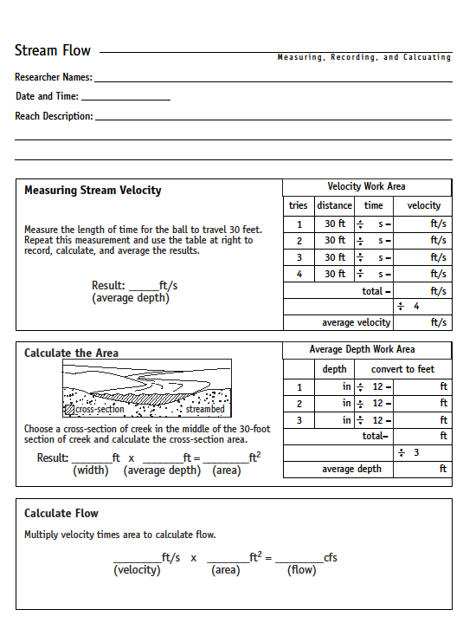

Appendix E: Fly Casting Details
This section of STREAM Keepers will introduce fly fishing and teach about fly fishing equipment, the proper stance, two styles of casting, and the importance of handling fish safely and quickly.

Class Size preferred:
  - 1 to 4 ratio of casting instructors to participants, or less

Equipment needed:
  - 4/5 weight rods and reels
  - A selection of barbless flies, forceps
  - Sunglasses or safety glasses for participants and instructors
  - Clippers and leader material
  - Optional: Caution signs (Fish and Onlookers Beware, Fly Fishing in Process, etc.) Introduction to the sport:
  - Fly-Fishing: A fun fresh and salt-water sport for catching trout, bream, bass, carp,
bonefish, tarpon, redfish etc.
  - Equipment and terms: Introduce the different parts of the rod and tackle including: rod, reel, line, leader, tippet, hook, dry fly, wet fly, barbed and barbless hooks.

Direct participants to follow these safety guidelines:

  - Wear sunglasses or safety glasses in order to protect the eyes.
  - Always check to be sure barbs are crimped.
  - When appropriate, place safety/warning cones around the casting area.
  - When casting, always check to be sure no one is in the backcast danger zone Casting:

Proper Stance:
    - Feet apart for secure balance
    - Reel facing down, thumb on top of the grip, tip of the rod held at eye level, one hand holding the line.

    - Depending on level of ability line can be held in hand opposite casting hand or simply held under the fingers of the casting hand.
    - The participant’s arm should be bent at a right angle.

Presentation cast:

    - Consists of a back cast, forward cast, and presentation of the fly on the water
    - These is no false casting in this cast. (False casting for beginners is a sure way to tangle leaders.)
    - A useful phrase is “snap pause snap”
    - Back cast should not be taken past the ear and forward cast should stop at eye level
    - If participants are struggling, instructors may ask permission to cover the student’s casting hand with the instructor’s hand in order to cast together. Casting together helps the participant feel and learn the proper casting cadence and rod position.
- Have participants practice their presentation cast. Walk around the group and give individual instruction to all of the participants. Make adjustments as need be. Make sure participants are not using too much wrist or taking the rod too far back.

Catching and releasing a fish:

- Emphasize the fact that the rod tip must always remain up and not pointed at the fish. Practice going backward and forward so the participant can practice letting the line out while the fish runs, and strip in the line when the fish approaches.
- Participants must be shown how to “strip in line”
- Emphasize use of barbless hooks
- Bring fish to hand quickly
- Never handle fish unless hands are wet
- If possible, leave fish in water while unhooking
- Use forceps to effectively unhook fish
- Return to water as soon as possible

Appendix F: Macroinvertebrate Sampling Techniques

Please be sure to read the STREAMwalk tips and safety guidelines.

For a printable Macroinvertebrate Key: www.troutintheclassroom.org/sites/www.troutintheclassroom.org/files/images/riverkey_0.pdf

Notes and terminology for your macroinvertebrates discussion with Stream Keeper participants:

There is a whole world of life in rivers and streams. Living alongside fish, amphibians, reptiles, and wildlife are macroinvertebrates—creatures that are large (macro) enough to be seen with the naked eye and that lack a backbone (invertebrate). In streams, most macroinvertebrates live under or attached to submerged rocks, logs, and plants. Like all living things, they need oxygen to breathe, water of the right temperature to thrive and reproduce in, suitable habitat, and the right kind of food.

Macroinvertebrates and crustaceans are an indicator species—in other words, their presence is used to assess the health of a waterbody. Any physical, chemical, or biological change in water quality that adversely affects living organisms is considered pollution. Some organisms are very sensitive to pollution, while others are more resilient and less vulnerable.

Many aquatic species rely on macroinvertebrates for food, including most species of fish (e.g., trout, bass, salmon). In turn, aquatic birds, including great blue herons and kingfishers, rely on the fish that feed on the macroinvertebrates.

Macroinvertebrates and crustaceans are, therefore, a very important component in the “web of life.”

Some macroinvertebrates are more sensitive to pollution than others, so if you find a large diversity of macroinvertebrates that cannot tolerate pollution, you have found a healthy stream. On the other hand, if you find only macroinvertebrates that can live in polluted conditions, your stream may have a problem.

Check with local monitoring organizations or local water quality officials. They may be willing to demonstrate correct monitoring techniques. Also, keep in mind that too much activity may have a negative impact on the stream’s aquatic life.

For observing macroinvertebrates, you will need:

•A bucket (5-gallon)
•A shallow white pan. (Alternatives: white plastic plate or the bottom of a white jug)
•Tweezers
•Ice cube trays filled with stream water (for sorting insects)
•Magnifying glass lens
•Spray bottles
•Field guides (optional)

Use one or more of the following methods to locate macroinvertebrates:

- Rock-rubbing method (For streams with riffle areas and rocky bottoms)

Remove several rocks from within a riffle area of your stream site. Try to choose rocks that are submerged during normal flow conditions. Each rock should be about 4 to 6 inches in diameter and should be easily moved (not embedded).

Either inspect the rock's surface for any living organisms or place the rock in a light-colored bucket or shallow pan, add some stream water, and brush the rock with your hands. Also look for clumps of gravel or leaves stuck to the rock. These clumps may be caddisfly houses but should not be dislodged. Just observe them and then return the rocks to the stream.

Stick-picking method. (For streams without riffles or a rock bottom)

Collect several sticks from inside the stream site, and place in a bucket filled with stream water. Select partially decomposed objects that have soft, pulpy wood and a lot of crevices and are found in the flowing water, but not buried in the bottom.

Examine the stick, making sure you hold it over the pan so no organisms are lost. Remember that the organisms will have sought shelter, and they could be hiding in loose bark or crevices.

After examining the sticks, it might be helpful to break up the woody material. Using tweezers, carefully remove anything that resembles a living organism and place it in the pan. Also examine the bucket contents for anything that has fallen off the sticks.

Leaf pack-sorting method. (For streams with or without a riffle or rock bottom.)

Remove several handfuls of submerged leaves from the stream and place them into a bucket. Remove the leaves one at a time and look closely for the presence of insects. Using tweezers, carefully remove anything that resembles a living organism and place it in a pan containing

stream water. Also, examine the water in the bucket contents to see if anything has fallen off the leaves.

Kick-net method.

Choose a site in the stream where a small riffle occurs (an area where water is flowing over rocks creating a light churning effect in the water). Enter the water below the study site and approach it by walking upstream so that you don't disturb the study area before the net is in place.
Insert the net into the water vertically, standing behind it (downstream), then tip the net downstream so that it is at a 45o angle to the water.
Place several medium-sized rocks on the bottom of the net to hold it down and prevent debris from flowing under it.

Start sampling in the collection area (about a one meter length upstream from the net).
- First, lift larger rocks in the collection area & scrub underwater with your fingers, to dislodge organisms
- After scrubbing use your feet to kick & stir up the streambed, in the collection area, for at least one minute.

Remove the rocks from the bottom of the net and then lift the bottoms of the poles out of the water (keep the top of the net above water at all times).

Carry the net out of the water & lay it on a flat surface or table for macroinvertebrate removal and ID.

Afterwards, be sure to rinse the kick-net in the stream, removing any debris and allow it to air dry.

Once macros are collected

After collecting macroinvertebrates, examine the types of organisms by gross morphological features (e.g., snails or worm-like). Use a magnifying glass lens to observe the organisms in water so you can clearly see the legs, gills, and tails.

Note the relative abundance of each type on the data sheet. Participants can use the ice trays filled with stream water to sort and group the insects (e.g., all the caddisflies in one, all the midges in another). Do this activity in the shade so that the insects do not die from the direct sunlight.

Also, it’s a good idea to keep a spray bottle on hand if the insects have been out of the water for an extended period of time. When finished, return all the organisms to the stream.

Many types of macroinvertebrates can be found in a healthy stream. Because different species can tolerate different levels of pollution, observing the variety and abundance of macroinvertebrates can give you a sense of the stream's health. For example, if pollution- tolerant organisms are plentiful and pollution intolerant ones are found only occasionally, this might indicate a problem in the stream. Types of organisms you may find include:

  - Worm-like organisms (like worms and leeches) either adhere to rocks or sticks or move slowly. They are generally tolerant of pollution.
  - Crustaceans include crayfish that look like lobsters or shrimp. They are generally somewhat tolerant of pollution.
  - Snail-like organisms include snails and clam-like organisms. They range from somewhat tolerant of pollution to somewhat intolerant.

Below is a picture of a caddisfly larva that has made a protective covering out of sticks and plant material.

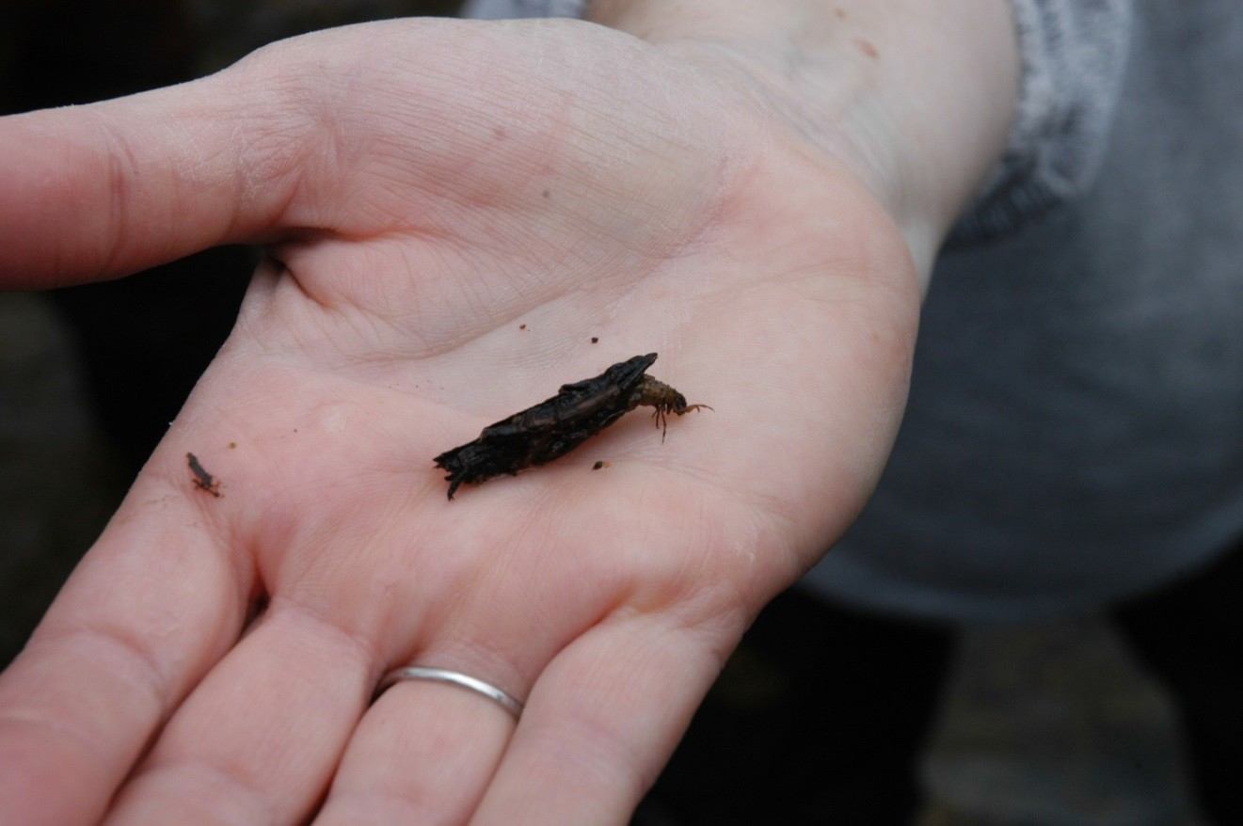

Appendix G: Macroinvertebrate Survey Data Sheet Location
Stream name: _ Date:

County: _ State:

Stream location (park or property):

Site (description of exact location of the stretch of stream you are studying:

What method did you use to collect macroinvertebrates?

Were macroinvertebrates present? Yes No

The diversity and abundance of underwater insects living in a particular stream are indicative of long-term water quality. Some of these insects are only present in streams of the highest quality, while others thrive in poor quality water. Mayflies (Ephemeroptera), Stoneflies (Plecoptera), and Caddisflies (Trichoptera), are often referred to as EPT, and these are the most sensitive of insect orders. The abundance of a high diversity of insect orders, including EPT, usually indicates a healthy stream. Often, headwater streams to not have sufficient nutrient levels to support a robust macroinvertebrate community. In these situations, focus on EPT.
Total number of taxa: (Ideal: 13+)
Total number of kinds of EPT: (Ideal: 7+)
Overall Stream Score (add two numbers): (Ideal: 20+)

Appendix H: Leave No Trace Principles
When it comes to STREAM Keepers activities, Leave No Trace is just as important as it is for other outdoor pursuits. Here are a few things to keep in mind:
- Plan Ahead and Prepare
-Know the local fishing and boating regulations for the area where you’ll fish. Obtain licenses and stamps and have them with you.
-Use a personal flotation device where required and/or appropriate.
-Learn to identify the different species of fish in the area where you’ll be fishing.
-Obey the limits on size and quantity of fish you are allowed to keep. Abide by regulations concerning types of bait and tackle permitted where you are fishing.
-Prepare for extreme weather, hazards, and emergencies.
-Plan your trip to avoid times of high use.

Travel and Camp on Durable Surfaces

-Durable surfaces include rock, gravel, water, established trails and campsites, sand, or snow.
-Concentrate use on existing trails, campsites, and boat launches.
-Focus activity in areas where vegetation is absent.
-Avoid trampling aquatic vegetation when wading. Refrain from wading in spawning areas when possible.
-Enter and leave water sources at places where the banks are low or where there are gravel bars.
-In pristine areas disperse use to prevent the creation of new campsites and trails.
-Protect riparian areas by camping at least 200 feet from lakes and streams.

Dispose of Waste Properly

-Pack it in, Pack it out. Inspect your camp and rest areas for trash or spilled foods. Pack out all monofilament fishing line, leftover live bait, and bait cups.
-Avoid using lead sinkers and jigs. If lead sinkers are found, pack out for proper disposal.
-Use established bathrooms when available. If not available, deposit solid human waste in catholes dug 6 to 8 inches deep and 200ft away from water sources.
-Check with local land managers for regulations on disposal of fish entrails. Pack out entrails when possible. If not possible, burial, deepwater deposition, or moving water deposition are acceptable options in most areas.
-To wash yourself or your dishes, carry water 200 feet away from streams or lakes and use small amounts of biodegradable soap. Scatter strained dishwater.

Leave What You Find

-When practicing “catch and release”, use barbless hooks and be sure to not injure the fish. Do not fight a fish to exhaustion, use a rod and line of sufficient strength, avoid suspending fish out of water by the fishing line. Keep fish in water when handling for release and do not touch gills.
-Carry and use needle-nose pliers or hemostats for hook removal.
-Take care not to introduce non-native species to water sources and surrounding areas. Pack out all un- used bait and dispose of properly (e.g. worms, minnows, leaches) and properly wash all equipment between fishing trips.
-Avoid transferring fish from one watershed to another.

Respect Wildlife

-Respect fish by humanely dispatching catches you are keeping with a quick blow to the back of the head with a rock or other solid object.
-Refrigerate or eat fish quickly to avoid wasting them. Check local regulations on using stringers.
-Use caution when cooking fish in bear country.
-Never feed wildlife. Feeding wildlife damages their health, alters natural behaviors, and exposes them to predators and other dangers.
-Control pets or leave them at home.

Be Considerate of Other Visitors

-Respect other visitors and protect the quality of their experience.
-Non-motorized crafts usually have right-of-way over powerboats: slower boats should keep to the right.
-If using a radio keep volume low or wear headphones, let nature’s sounds prevail.
-Pick campsites that are away from shoreline or trails and avoid crowding other visitors.

Appendix I: Free Time Ideas
Free time in nature is critical for participants to do their own exploring and make their own observations about the natural world. Free time needs to be built into a STREAM Keepers field day.
Guidelines for Free Time reflection:
  - Don’t make suggestions to the whole group about what they can do and allow them to discover for themselves how they want to pass the time. If a participant really needs a suggestion, draw from the prompts listed below.
  - Review safety guidelines and boundaries for free time.
  - Allow at least half an hour for free time.
  - Provide optional tools and resources for them to use. This can include hand lenses, measuring tools, art supplies, writing utensils, field guides.
  - Allow them to spend the time alone or in pairs, but encourage them to not be in groups larger than three.
  - Remember that anything respectful and observant is allowed. It might not look like learning or engagement to a volunteer leader, but it is all important. Their activities might include poking the stream with a stick, watching birds, sitting with their eyes closed, writing, drawing, wandering, etc.
Possible free time activities prompts:
  - Build a boat out of all natural materials you find lying on the ground.
  - Look at the world around you through a hand lens.
  - Turn over a rock or log. Look. Then replace it gently.
  - Sit very still next to the stream, especially near a pool. Look. Listen.
  - Climb a tree. (If working with children, check in with the adults about this one.)
  - Stalk a butterfly, grasshopper, or frog.
  - Find all the different birds in your location. Use binoculars if necessary.
  - Pick up litter.
  - Get a small team together to collect aquatic macroinvertebrates.
  - Swish an insect net through tall grass.

Appendix J: Other Resources/Suppliers List

You can find many of the supplies and materials for your STREAM Keepers event at local stores. For some specialized items like kick nets, we recommend ordering from an on-line source: www.acornnaturalists.com
www.forestry-suppliers.com/

For the beads necessary to complete the STREAM Keepers bracelet/pin, go to www.shipwreckbeads.com the no-coil pins are available at craft shops.

Nine bead designs need to be purchased from Shipwreck Beads:
ME5481-S (dragonfly bead to represent insects) RP3003-S (feather bead to represent animals) 58SV212 (clear bead to represent water) 18HR153-T (horn tube to represent wood) 9IC027-W (india bead to represent rock) 6RC512-M 9 (crystal bead to represent riffles) 9IC164 (turquoise bead to represent sky)
6RC281-3 (light green bead to represent short plants) 9IC284 (dark green bead to represent trees)

