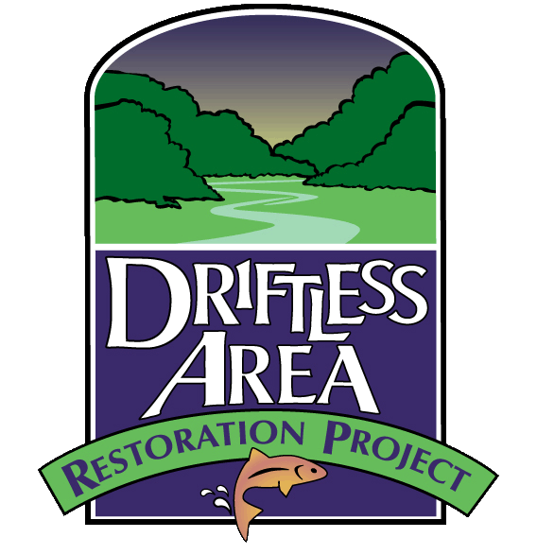
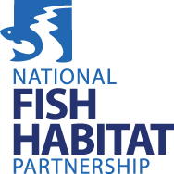
Driftless Area Restoration Effort
Project Proposal

Deadline: February 2, 2024

Contact Information:
Project Officer: Project Co-Officer
Name ________________ Name ________________
Affiliation ________________ Affiliation ________________
Mailing address ________________ Mailing address ________________
email address _________________ email address ________________
phone number _________________ phone number ________________

Title of the project: (max chars: 100)

Location:
Watershed or subwatershed name:

Name of stream/river, County, State:

Township, Section and Range:

GPS coordinates (upper end of project area):
Lat: Long: decimal degrees (NAD-1983)

Record Congressional District(s):
(eg. WI-3, IL-2)

What type of action would you like considered (Place “X” for the one that applies)

- Habitat enhancement or restoration_______ (I.e. Riparian, wetland, instream, barrier removal)
- Scientific Assessments __________ (i.e. population, habitat, barrier assessments)
- Outreach/Education __________ (i.e. landowner engagement, outreach materials)
- Partnership support project __________

FWS NFHP Funding Request:___________ ($15,000 - $75,000)

Non federal Match (1:1 inclusive of both types): In-Kind ___________ Match: Cash ___________

Project Total: ___________ (include match, other federal contributions, request amount=project total)
Section 1.

PROJECT ABSTRACT/Short Description
The project description should be in plain language such that reviewers and public can understand without viewing the full project proposal. Abstract should include a succinct description of the project purpose or need, objectives, major activities to be performed, deliverables, and expected outcomes. Abstract will be used in program databases and placed on USASpending.gov for public use if project is awarded. (Please do not include personally identifiable, sensitive, or proprietary information in the Project Abstract Summary.
(Project Abstract is limited to 4,000 characters or less.)

PRoject Information

- Statement of Need: Explain the importance (need) of the proposed project. Identify the conservation issue, problem, or opportunity to be addressed. Identify the negative result of taking no action. (Provide evidence such as results from surveys, research or other data to demonstrate that the need is real and not perceived.)

- Project Goals and Objectives: State the goal(s) of the project, the specific and measurable objectives,
and how they will address the fhp’s priorities. DARE Priorities are: Improve riparian and instream habitat on cold, cool and warmwater streams in the Driftless Area in support of native species; Monitor and evaluate conservation actions; Increase quantity and quality of angling and recreation opportunities; Increase awareness of Driftless Area resources and the importance of aquatic conservation and restoration through outreach and education. Objectives are the specific actions to be taken to reach the stated objectives(s). (Objectives should be written in an active tense and using action verbs such as construct, survey, train, research, establish, repair, conduct, provide, acquire.)

- Project Activities, Methods, and Timeline:
Describe or list proposed project activities:

Describe the approach or methods and explain how it relates to the stated objectives. Provide a detailed description of the method(s) to be used to carry out each major activity.

Provide a timeline indicating roughly when activities or project milestones are to be accomplished. Timeline can be in table form or bulleted format. (The timeline should not propose specific dates but instead group activities by month for each month over the entire proposed project period.

- Description of Entity Undertaking the Project: Provide a brief description of the applicant/entity, experience, and capability to successfully carry out proposed project. Describe other participating entities and/or individuals and identify the proposed activities each entity is responsible for managing.

- Description of Monitoring Plan. Based on the objectives for your construction or non construction project, describe your monitoring/evaluation plan. Identify what you will measure (i.e. quantitative/quantifiable indicators) and how (i.e., methods, sample size, survey tools). If project is funded, a written summary of your accomplishments or results and conclusions (assessments) will be required at the completion of your project.

PERFORMANCE MEASURES

Amount and type of habitat affected (Fill in boxes)
In-stream miles restored/enhanced
Riparian miles restored/enhanced
Riparian acres restored/enhanced
(length of stream x width of area)
Number of instream structures placed
Wetland acres restored/enhanced
Upland acres restored/enhanced
Other habitat type restored/enhanced (specify)
Number of management populations assessed
Total number of miles in-stream/shoreline habitat assessed
Number of acres of upland habitat assessed
Number of acres of wetland habitat assessed
Total number of fish passage barriers removed or bypassed
Number of miles re-opened to fish passage
Number of acres re-opened to fish passage
Recreational fishing enhancements (number of features)
Length of new public fishing access

Conservation Actions Taken (Check all that apply)

Install upland Best Management Practices
Stream protection/ Protect healthy habitat
Native prairie/Grassland restoration
Riparian corridor protection
Streambank stabilization
Restore native riparian vegetation
Reduce nutrient loading
Reduce sediment loading
Restore riparian habitat/Buffers
Improve physical fish habitat (woody habitat, rock weirs, veins, woody debris, etc.)
Restore natural stream channel form
Reconnect aquatic habitat
Control/eradicate invasive species
Restore natural stream flow/Hydrological processes
Remove fish barrier
Improve natural variability in river and stream flows
Improve floodplain habitat
Restore water temperatures
Improve sediment transport
Restore wetlands

Support National Fish Habitat Partnership’s Goals
(Check all that apply)
- Protect & maintain intact and healthy aquatic systems
- Prevent further degradation of fish habitats that have been adversely affected
- Reverse declines in the quality & quantity of aquatic habitats to improve the overall health of fish & other aquatic organisms
- Increase the quality & quantity of fish habitat that support a broad natural diversity of fish/aquatic species.

Primary native species:

Secondary native species:

Other species/communities:

BUDGET:
For projects that are predominantly construction costs, utilize the 1A budget template. Permitting related costs may be included in this template. For projects that are predominantly non-construction (planning, outreach, assessment,), utilize the 1B budget template.
See Attachment 1A- Budget Construction
See Attachment 1B- Non Construction

Proposed Outreach
- Describe any planned outreach or educational component(s) and partners(s) involved.
(max chars: 500) If project is funded, a written summary of your outreach/educational activities will be required at the completion of your project.

- What methods will you use to promote the project if it is funded? (max chars: 500)

- Are there any unique aspects about the project? (max chars: 500)

Public interest

- Describe the public interest in this resource. Why is this a good place to invest conservation dollars? (max chars: 500)
- Will this project enhance recreational fishing? Yes No N/A (Place “X”)

- Will public fishing access be available? Yes No N/A (Place “X”)

- Is the project in an area of special conservation designation? (Place “X” for those that apply)
- State Conservation Opportunity Area
- Ten Waters to Watch
- Ramsar (Convention on Wetlands of International Importance)
- Joint Venture Focal Area
- National Blueway
- Brook Trout Reserve or state fisheries priority
- Class I Trout Stream
- Class II Trout Stream
- Class III Trout Stream
- Protected stream/segment
- 303d listed/9KE & Watershed plan (WI & IL)/1W1P (MN)/WMP (IA)
- Biologically significant
- Designated threatened and endangered critical habitat (federal and state)
- Other
- Land ownership at project location (check all that apply for project area – Note: more attention will be given to privately owned – farmed land)
Federal ____ State____ County____ City____ Private____
Non-governmental Organization____ Other_____

Conservation Easements
The value of new conservation easements may be utilized as non-federal match.
Is a conservation easement in place or in the process of purchase? Yes ___ NO ___ (Place “X”)
If you answered yes above, is it a new or existing easement? New____ (Place “X”)
Is the easement perpetual? Yes____ No____ (Place “X”)
If no, what is the length of easement ______ (years)

FEDERAL FUNDING
(If awarded funding, you will be required to complete SAM.gov registration and registration within the Federal ASAP payment system. It is strongly recommended that you complete your SAM.gov registration prior to submitting your application or within 60 days of submitting your application for funding in order to avoid delays in receiving your award.)

- Have you received Federal funding in the last 5 years? Yes No (Place “X”)
- Do you have a current SAMS registration? Yes No (Place “X”)
- Do you have an active federal ASAP ID that to receive funds? Yes No (Place “X”)

If submitted proposal is a construction project, please complete questions 4--8.

- Have you completed at least 30% construction plans for the project? If yes, please provide draft designs with your submission. If no, please describe your design completion process to ensure that your timeline will align with the intended funding cycle. (Reminder that funding sought in this proposal is anticipated to be available in July 2025).

- Has National Environmental Policy Act (NEPA) been completed on this project prior to making a funding request?
Yes No (Place “X”) (Please attach any NEPA Documentation)
- Has the (Endangered/Threatened Species Review) with State Natural Resource Agency been completed?
Yes No (Place “X”) (Please attach documentation)

- Has the historic/cultural review been completed?
Yes No (Place “X”) (Please attach documentation).
If no was selected, when is review expected to be completed and who is conducting that work? Applicant is responsible for having the necessary archaeological surveys completed and providing copies of the report to USFWS in order for the agency to complete its compliance responsibilities.

- What are the necessary permits needed to initiate construction?

- Have permit applications been submitted?
- Have permits been received?

Project Completion

What is your approximate start/end date for this project _____/ _____ (indicate month/year)
(Projects must be completed in 2 years)
Section 2.

Watershed level planning
Please provide any background information necessary to adequately address the below questions.
Enter N/A if question is non-applicable

- Is the proposed project part of a larger restoration effort on the stream or in the watershed? If
so, what are the general stream or watershed goals or please provide the citation and/or web link to the stream or watershed strategic or management plan(s).

- Are there any existing or proposed protection/restoration efforts (riparian, upland, mgt areas, other) in and adjacent to the project area that will help ensure long term benefits?

- How does the project address climate change adaptation?

- What is the current land use at the project site? (Please choose from the following):
Cropland in current production
Fallow land, former cropland
Grazed/pasture
Orchard, grove, vineyard
Other Ag land
Grassland/Prairie
Wetland
Riparian corridor (>65’ wide)
Forest
Park/Public Lands – State, County
Urban
Resort/Tourism

- What is the current land use in the watershed? ( Please utilize the following tools to estimate land use in your watershed: )

- What are the current/future plans for upland conservation/Best Management Practices in the watershed where the proposed restoration/enhancement project occurs?

Section 3.

MAP OF PROJECT AREA
Please provide a map of the proposed project area showing the scope and location of project.
- • Recommended mapping sites: Surface Water Data Viewer (Wisconsin), Watershed Health Assessment Framework (Minnesota), Illinois EPA 2020/2022 Integrated Report Web App, BioNet (Iowa)

PHOTOGRAPH(S) OF PROJECT AREA (Required)
Please include up to two photographs of proposed project area. Each photo should be in JPG, TIFF, GIF, WMF or bitmap format and accompanied by:
- • A short, descriptive caption
- • Credit: Photographer’s name/organization

DOCUMENTS Please attach appropriate planning documents, work plans, construction designs, maps etc. in PDF format. Notice –final construction designs must be turned prior to project start, if this is a construction/ground-disturbance project.

